ANSON PRIMARY SCHOOL
Class 1 – Week 6
Weekly Learning Tasks
Why have Weekly Learning Tasks been created?
Weekly learning tasks have been created as a result of the ongoing risk of schools shutting due to the Coronavirus outbreak across the UK. Based on this very real and increasing threat. Class teachers have therefore written a set of weekly learning tasks which can be completed by your child whilst schools are closed for a set duration. In creating the weekly learning tasks we fully acknowledge that they cannot replace the quality of learning your child receives at school however, our complete focus has been on creating a set of tasks that all children can access to maximise their learning whilst at home.
What are the aims of the Weekly Learning Tasks?
- To create age specific learning opportunities for primary school children.
- To create a resource for parents that is easy to access and use - the focus is on parents being able to help deliver the content or children accessing it independently.
- Key learning is linked to the Early Years Foundation Stage.
- To enable children to continue with their learning at home during an enforced shutdown.
- To provide structure and focus to each day when an enforced shutdown occurs.
- To centralise online learning resources and links into an easy to manage format for families.
How do I use the Learning Tasks?
As a parent your first step is to read the ideas outlined in this document and choose 1 task from each area to do that day, there is no set time that you should spend on each task as you may wish for your child to spend less or more time on activities.

A mailbox has been set up to receive emails only for any work set outside of the educational programs we use. Please feel free to send work, photographs to your class teacher using the following email address is: anson.class1@tssmat.staffs.sch.uk
We are unable to reply to any emails sent to this address.
If you wish to contact the class teacher please do so as usual by emailing the office email address. anson.office@tssmat.staffs.sch.uk. The class teacher will make every effort to respond within 2 working days.

Online Programs
(Logins for these programs found in the front of your child’s homework diaries)
Bug Club  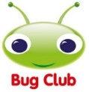 | https://www.activelearnprimary.co.uk/login?c=0  Differentiated Reading Books, which asks your child questions about the texts.
Education City | https://www.educationcity.com/  Age appropriate Literacy and Numeracy Games  Games the teacher has set will be found on your child’s MyCity Page.  We encourage a score of 80% or more, to ‘Pass’ the game.
Purple Mash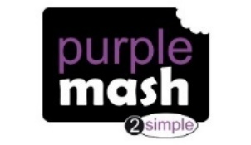 | https://www.purplemash.com/login/  Purple Mash hosts an exciting mash-up of curriculum focused activities. Work the teacher has set can be found on your child’s 2do Page.
Doodlemaths/  Doodletables | https://www.doodlemaths.com/ Also available on the APP Store.  Maths and Times tables Programs.  Work the teacher has set can be found on the ‘extras’ part of the Doodlemaths program.
SpellingShed | https://www.spellingshed.com/en-gb /  Also available on the APP Store Weekly spelling lists are uploaded on this program with activities to try to practise spelling these words.
Teach Your Monster to Read | https://www.teachyourmonstertoread.com/  Also available on the APP Store with age and phonics level appropriate games.

Class 1 Weekly Learning Tasks Week 6
Weekly Maths Tasks (Aim to do 1 per day) | Weekly Reading Tasks (Aim to do 1 per day)
Maths focus this week: SSM: Length  - This week we are looking at length – discuss these words  - long, short  - tall, small  - big, little  - tallest, shortest  - the same as  - Complete Maths comparing length activity on Education City  - Complete Maths comparing activities on Purplemash  - Doodlemaths 5aday and Extras - your child has an individual login to access this.  - Find objects in your home – begin with finding 2 different sized objects – decide which is taller or shorter. Then find 3 objects and order them smallest to tallest. Challenge yourself with 4,5,6,7,8 objects!  Top tip – when you measure 2 objects next to each other you must make sure the bottom of the objects is being measured from the same points – maybe against a line  - Compare objects using non-standard units – find objects and measure them using cubes/paper clips/beads/counters (as long as it’s the same object) count how many cubes does it take to measure a book  - Order your family by height – stand 2 people back to back and see whose head is higher up. Put your family in a line shortest to tallest.  - Measure everyone’s shoe size in your family – whose is the biggest – can you put your family in order of biggest shoe size to smallest? | - Children to read to parents daily, reading a book on Bug Club. Complete the questions about the story on each page by clicking on the bugs face on the page.  - Read to your child, you could choose 2 books each day and your child can vote for which book they would like to have read to them. You could even have a whole family vote where everyone votes for the book they would like to hear and then count the votes to see which story has the most.  - Visit Oxford Owl for free eBooks that link to your child’s book band. You can create a free account at Oxford Owl ebook collection. Complete the linked Play activities for each book.  This weeks story:  Rumble in the Jungle by Giles Andreae  https://www.youtube.com/watch?v=m9W5upzGfFU  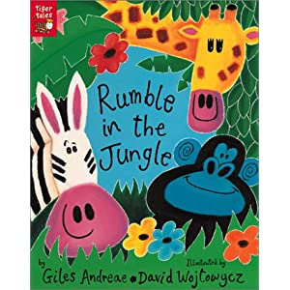  - Whilst you are listening or reading the story this week, listen out for rhyming words, there are lots and lots of rhymes at the end of each phrase can you find them? You could write down the words that rhyme together!
Weekly Phonics Tasks (Aim to do 1 per day) | Weekly Writing Tasks (Aim to do 1 per day)
- Daily Phonics - practise Sounds and Tricky words in Phonics Bag – this week teach your child how to read and write tricky word > ‘out’  - Practice reading this new tricky word – Go on Phonics Play > Phase 4 > Train your brain . This will show you the tricky parts to the word and how to keep practising it until you remember!  https://new.phonicsplay.co.uk/resources/phase/4/train-your-brain-ph4  - Phase 3 – Check which ones your child is still unsure of and continue to practise these sounds daily.  - Use your Phase 2 Phonics Bag sound cards and add 1 Phase 3 card to your word. Blend it out loud – have a go at writing these once you have read them  e.g. Ch/a/m/p = champ sh/i/f/t = shift  - Complete Education City > My City > phonics activities  - Teach Your Monster to Read – log into your account to practise the sounds and ‘trickies’.  Handwriting  - Practise your letter formation this week, focusing on your cursive lead ins. Copy the Sky Writer formation into a tray of sand, use your finger in paint, water and a paintbrush outside on the floor to keep practising in lots of different ways  https://www.ictgames.com/mobilePage/skyWriter/index.html | 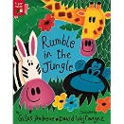  Rumble in the Jungle by Giles Andreae  - Rhyming words – can you practice reading rhyming words on the bottom of this document? Try sounding them out and then a family member could read one and challenge you to write it.  - Can you find words that rhyme with, write them all down  hat, bat ……  rug, tug ……  car, star ……  log, frog ……  - In our story there are lots of different jungle animals – can you think of a jungle animal that is not in the story and write a sentence/s to say what they do? You could make it into your very own page from the story, so we could just add it inside the book without anyone noticing!!  - I have attached a picture to the bottom of this document with a Jungle Scene – what can you see? Can you write words or sentences to describe what you can see. If you are writing sentences have a go at sounding out the words by yourself, this way you are practising your phonics as you are writing! Then go back and check you have used capital letters, finger spaces and full stops! I can’t wait to see your super sentences Class 1!
Learning Project – to be done throughout the week - Animals
The project this week aims to provide opportunities for your child to learn more about the topic Animals. Below there is a variety of tasks for you to complete throughout the course of the week, you can choose when you do each of these activities and you could even create some activities of your own to do with our topic.

- Our story Rumble in the Jungle tells us all about animals that live in a jungle – can you find more out about these animals?
- Chimpanzee
- Lion
- Elephant
- Zebra
- Snake
- Giraffe
- Hippopotamus
- Crocodile
- Rhinoceros
- Gazelle
- Gorilla
- Leopard
- Tiger
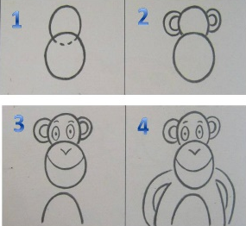
- I have been practising my drawing skills – I have found a helpful guide (in documents section of Class 1’s page) that shows you how to draw Jungle animals really easily! I thought I would share it with you so that you can have fun learning a new skill too! You and your family could have a drawing challenge where everyone follows the step by step guide and when everyone has finished have a vote to see whose jungle animal looks the best! (or closest to any kind of animal!!) Have fun!

- Watch the 360’ video exploring the jungles and rainforests, you could watch this on a phone or tablet so you can move the device around the room as if you are really there – tilt your device up to the ceiling and you will be able to see the top of the jungle – tilt it down to the floor…what can you see. This works best if you turn the lights off and turn the volume up, it feels like you’re really there! Describe what you can see, what can you hear, how do you feel, do you think it would feel cold or hot? Each part of the video explores different scenes so keep watching through them all. Explore all around! Enjoy!
- Rainforest - https://www.youtube.com/watch?v=uUgXbMwjvBE

- After watching the video exploring the jungle - Can you make a jungle scene – use craft materials or collect materials from your garden (grass, twigs, petals, leaves) to make a creative jungle. Research what kinds of things you would see in a jungle…lots of trees and plants, think about the main colours you would need – greens and browns! I look forward to seeing your creations!
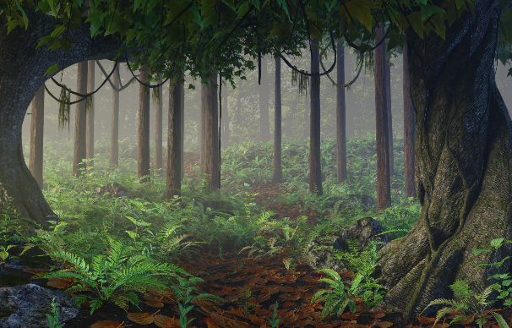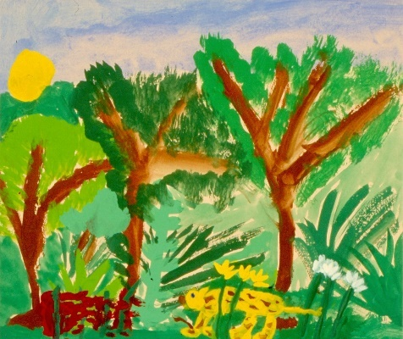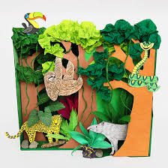

PE
- Joe Wicks Live PE Lessons each morning at 9 am.

- Go Noodle with the family or have a family workout.

- Cosmic Yoga videos are lots of fun!

- Can you create your own work out for your family? You could make an obstacle course in your house or in the garden, you could time each of your family members to see who completes it the fastest.
Useful Websites
- Oxford Owl for home - https://www.oxfordowl.co.uk/
Providing free access to online books for parents

- Twinkl – https://www.twinkl.co.uk/
Providing free access to home learning packs

- Phonics Play – https://www.phonicsplay.co.uk/
A fantastic website for your child to independently access phonics games where you can select specific sounds or tricky words to focus on. Currently providing a free login in march to access from home.

- Story Online – https://www.storylineonline.net/
Access to a wide variety of books read aloud for your child to listen to

- Vooks - https://www.vooks.com/
Access to a wide variety of books – currently free

- Sky Writer - https://www.ictgames.com/mobilePage/skyWriter/index.html
Cursive hand-writing practice

- Phonics Bloom - https://www.phonicsbloom.com/

- BBC Supermovers - https://www.bbc.co.uk/teach/supermovers

- Topmarks - https://www.topmarks.co.uk/Search.aspx?Subject=37
A website full of interactive games

- ICT Games - http://www.ictgames.com/
A website full of interactive games

-Lalilo - https://www.lalilo.com/
This site is completely free to sign up to and use at the moment. It is full of Phonics and Reading games that you can use with your child.

