ANSON PRIMARY SCHOOL
Class 1 – Week 7
Weekly Learning Tasks
Why have Weekly Learning Tasks been created?
Weekly learning tasks have been created as a result of the ongoing risk of schools shutting due to the Coronavirus outbreak across the UK. Based on this very real and increasing threat. Class teachers have therefore written a set of weekly learning tasks which can be completed by your child whilst schools are closed for a set duration. In creating the weekly learning tasks we fully acknowledge that they cannot replace the quality of learning your child receives at school however, our complete focus has been on creating a set of tasks that all children can access to maximise their learning whilst at home.
What are the aims of the Weekly Learning Tasks?
- To create age specific learning opportunities for primary school children.
- To create a resource for parents that is easy to access and use - the focus is on parents being able to help deliver the content or children accessing it independently.
- Key learning is linked to the Early Years Foundation Stage.
- To enable children to continue with their learning at home during an enforced shutdown.
- To provide structure and focus to each day when an enforced shutdown occurs.
- To centralise online learning resources and links into an easy to manage format for families.
How do I use the Learning Tasks?
As a parent your first step is to read the ideas outlined in this document and choose 1 task from each area to do that day, there is no set time that you should spend on each task as you may wish for your child to spend less or more time on activities.

A mailbox has been set up to receive emails only for any work set outside of the educational programs we use. Please feel free to send work, photographs to your class teacher using the following email address is: anson.class1@tssmat.staffs.sch.uk
We are unable to reply to any emails sent to this address.
If you wish to contact the class teacher please do so as usual by emailing the office email address. anson.office@tssmat.staffs.sch.uk. The class teacher will make every effort to respond within 2 working days.

Online Programs
(Logins for these programs found in the front of your child’s homework diaries)
Bug Club  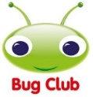 | https://www.activelearnprimary.co.uk/login?c=0  Differentiated Reading Books, which asks your child questions about the texts.
Education City | https://www.educationcity.com/  Age appropriate Literacy and Numeracy Games  Games the teacher has set will be found on your child’s MyCity Page.  We encourage a score of 80% or more, to ‘Pass’ the game.
Purple Mash | https://www.purplemash.com/login/  Purple Mash hosts an exciting mash-up of curriculum focused activities. Work the teacher has set can be found on your child’s 2do Page.
Doodlemaths/  Doodletables | https://www.doodlemaths.com/ Also available on the APP Store.  Maths and Times tables Programs.  Work the teacher has set can be found on the ‘extras’ part of the Doodlemaths program.
SpellingShed | https://www.spellingshed.com/en-gb /  Also available on the APP Store Weekly spelling lists are uploaded on this program with activities to try to practise spelling these words.
Teach Your Monster to Read | https://www.teachyourmonstertoread.com/  Also available on the APP Store with age and phonics level appropriate games.

Class 1 Weekly Learning Tasks Week 7
Weekly Maths Tasks (Aim to do 1 per day) | Weekly Reading Tasks (Aim to do 1 per day)
Maths focus this week: SSM: Capacity  - This week we are looking at Measures – Capacity – discuss these words  - full - measure  - empty - volume  - half full - capacity  - half empty - nearly empty/full  - Complete Maths activity on Education City  - Complete Maths activities on Purplemash  - Doodlemaths 5aday and Extras - your child has an individual login to access this.  - Collect a variety of tubs, cups, bowls, buckets, bottles, tins, spoons, jugs – anything that can hold water/sand/rice inside. Discuss the words above and see if you get your containers to match each word e.g. fill the bottle to the top – Full.  - Read the letter from Finley the Fish (document attached to bottom of this page) – find containers around your home, can you work out ways to figure out which containers would be best for Finley the Fish? Could you count how many cup fulls they take to fill? Do tall containers contain more? Is it wide enough to swim around in?  - Measure each of the containers by using a small cup or pot and seeing how many ‘cup fulls’ of water it takes to fill them. Can you compare two containers, which took more to fill? Does this mean this container holds more water? Engage in lots of discussion about sizes of containers, you could estimate beforehand which will hold the most/least. | - Children to read to parents daily, reading a book on Bug Club. Complete the questions about the story on each page by clicking on the bugs face on the page.  - Read to your child, you could choose 2 books each day and your child can vote for which book they would like to have read to them. You could even have a whole family vote where everyone votes for the book they would like to hear and then count the votes to see which story has the most.  - Visit Oxford Owl for free eBooks that link to your child’s book band. You can create a free account at Oxford Owl ebook collection. Complete the linked Play activities for each book.  This weeks story:  Handa’s Surprise by Eileen Browne  You can read the book if you have it at home or you can watch this animated version of the story  https://www.youtube.com/watch?v=ocnRQi89nK8  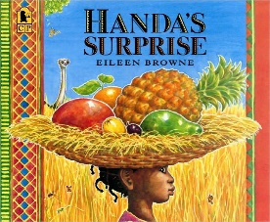  Look at the cover of this book, what do you think the book will be about? Why do you think she has a basket of fruit? Discuss what you think might happen in the story. Do you think it will be a happy ending to the story?
Weekly Phonics Tasks (Aim to do 1 per day) | Weekly Writing Tasks (Aim to do 1 per day)
- Daily Phonics - practise Sounds and Tricky words in Phonics Bag – this week teach your child how to read and write tricky word > ‘one’  - Practice reading this new tricky word – Go on Phonics Play > Phase 4 > Train your brain . This will show you the tricky parts to the word and how to keep practising it until you remember!  https://new.phonicsplay.co.uk/resources/phase/4/train-your-brain-ph4  - Phase 3 – Keep checking which ones your child is still unsure of and continue to practise these sounds daily.  - Practise reading and writing and remembering how to spell these High Frequency Words  - Complete Purplemash > 2Dos > phonics Cloze activities  - Teach Your Monster to Read – log into your account to practise the sounds and ‘trickies’. | 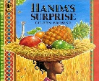  Handa’s Surprise by Eileen Browne  - Write words that describe each fruit from Handa’s basket (pictures of fruit attached to the bottom of the page). For an extra challenge you could write sentences to describe each fruit. What it looks like or what you think it might taste or feels like!  - What animals could you see in the story? Can you write down the animals you spotted; you could give each animal a name! Write down the names you’ve given them E.g. Edward the Elephant!  - Chilli Challenge – can you write a letter to Handa to explain what happened to the fruit and why it all disappeared!  To Handa,  On your trip to see your friend…  From…  - Name writing – Can you practise writing your full name, you might be used to writing your first name, but can you recognise and write your middle or last names? Practise writing your name over the week! Don’t forget your cursive lead ins and outs!
Learning Project – to be done throughout the week - Animals
The project this week aims to provide opportunities for your child to learn more about the topic Animals. Below there is a variety of tasks for you to complete throughout the course of the week, you can choose when you do each of these activities and you could even create some activities of your own to do with our topic.

- There are lots of fruits in Handa’s basket, have you tried them all before? Do you like all of these fruits? Try some fruits you have not eaten before, and describe what they look, feel and taste like!

- Have a go at making your own playdough, following the recipe attached to the bottom of this document and make your favourite animals!
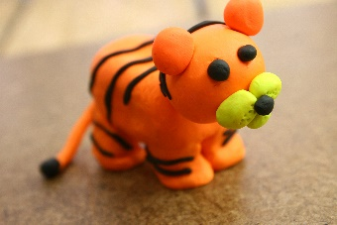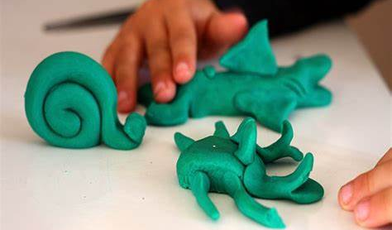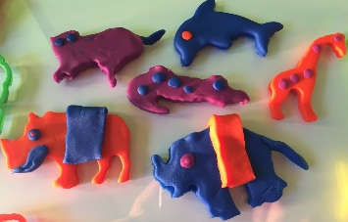

- Habitats – what does this mean? Research these four different environments that animals live in Jungle, Desert, Ocean, Antarctic – how are they different? What would you see if you were there? What kind of things would you need to pack if you were to live there?

- Watch this video clip – this shows how different animals suit their habitats e.g. camels have long eyelashes to stop the sand from blowing into their eyes,
https://www.bbc.co.uk/bitesize/clips/zyx76sg

- Now you’ve looked into different environments animals live in, could you create your very own animal for one of these environments, what features would it need to survive there? If your animal was to live in the ocean, it would need gills and fins but if your animal was to live somewhere very cold, it would need thick skin or fur to keep it warm! Have fun inventing your own animal, I would love to see your creations and the reasons why you gave your animals its features!
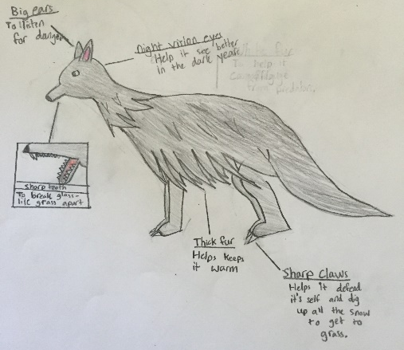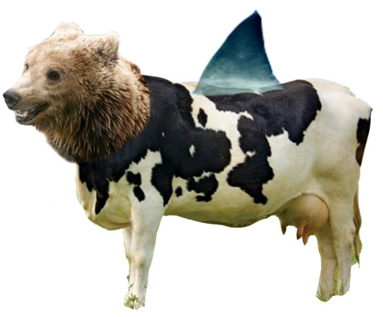
- Create a different animal on Purplemash, you can use the textured paints to help you make even more features on your animal. I can not wait to see them!
- On Education City – can you complete the Animals Topic activities, looking at habitats and features of the animals.
PE
- Joe Wicks Live PE Lessons each morning at 9 am.

- Go Noodle with the family or have a family workout.

- Cosmic Yoga videos are lots of fun!

- Can you create your own work out for your family? You could make an obstacle course in your house or in the garden, you could time each of your family members to see who completes it the fastest.
Useful Websites
- Oxford Owl for home - https://www.oxfordowl.co.uk/
Providing free access to online books for parents

- Twinkl – https://www.twinkl.co.uk/
Providing free access to home learning packs

- Phonics Play – https://www.phonicsplay.co.uk/
A fantastic website for your child to independently access phonics games where you can select specific sounds or tricky words to focus on. Currently providing a free login in march to access from home.

- Story Online – https://www.storylineonline.net/
Access to a wide variety of books read aloud for your child to listen to

- Vooks - https://www.vooks.com/
Access to a wide variety of books – currently free

- Sky Writer - https://www.ictgames.com/mobilePage/skyWriter/index.html
Cursive hand-writing practice

- Phonics Bloom - https://www.phonicsbloom.com/

- BBC Supermovers - https://www.bbc.co.uk/teach/supermovers

- Topmarks - https://www.topmarks.co.uk/Search.aspx?Subject=37
A website full of interactive games

- ICT Games - http://www.ictgames.com/
A website full of interactive games

-Lalilo - https://www.lalilo.com/
This site is completely free to sign up to and use at the moment. It is full of Phonics and Reading games that you can use with your child.

Maths - Capacity - Finley the Fish

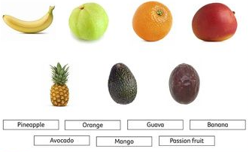

Playdough recipe

Ingredients
- 2 cups plain flour
- 2 tablespoons vegetable oil
- 1/2 cup salt
- 2 tablespoons cream of tartar
- Up to 1.5 cups boiling water (add until it feels just right)
- food colouring (optional)

Method:
- Mix the flour, salt, cream of tartar and oil in a large mixing bowl
- Add food colouring TO the boiling water then into the dry ingredients (colour optional)
- Stir continuously until it becomes a sticky, combined dough
- Allow it to cool down then take it out of the bowl and knead it vigorously for a couple of minutes until all of the stickiness has gone. * This is the most important part of the process, so keep at it until it’s the perfect consistency!*
- (If it remains a little sticky then add a touch more flour until just right)
Enjoy!

