ANSON PRIMARY SCHOOL
Class 1 – Week 8
Weekly Learning Tasks
Why have Weekly Learning Tasks been created?
Weekly learning tasks have been created as a result of the ongoing risk of schools shutting due to the Coronavirus outbreak across the UK. Based on this very real and increasing threat. Class teachers have therefore written a set of weekly learning tasks which can be completed by your child whilst schools are closed for a set duration. In creating the weekly learning tasks we fully acknowledge that they cannot replace the quality of learning your child receives at school however, our complete focus has been on creating a set of tasks that all children can access to maximise their learning whilst at home.
What are the aims of the Weekly Learning Tasks?
- To create age specific learning opportunities for primary school children.
- To create a resource for parents that is easy to access and use - the focus is on parents being able to help deliver the content or children accessing it independently.
- Key learning is linked to the Early Years Foundation Stage.
- To enable children to continue with their learning at home during an enforced shutdown.
- To provide structure and focus to each day when an enforced shutdown occurs.
- To centralise online learning resources and links into an easy to manage format for families.
How do I use the Learning Tasks?
As a parent your first step is to read the ideas outlined in this document and choose 1 task from each area to do that day, there is no set time that you should spend on each task as you may wish for your child to spend less or more time on activities.

A mailbox has been set up to receive emails only for any work set outside of the educational programs we use. Please feel free to send work, photographs to your class teacher using the following email address is: anson.class1@tssmat.staffs.sch.uk
We are unable to reply to any emails sent to this address.
If you wish to contact the class teacher please do so as usual by emailing the office email address. anson.office@tssmat.staffs.sch.uk. The class teacher will make every effort to respond within 2 working days.

Online Programs
(Logins for these programs found in the front of your child’s homework diaries)
Bug Club  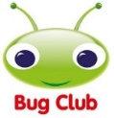 | https://www.activelearnprimary.co.uk/login?c=0  Differentiated Reading Books, which asks your child questions about the texts.
Education City | https://www.educationcity.com/  Age appropriate Literacy and Numeracy Games  Games the teacher has set will be found on your child’s MyCity Page.  We encourage a score of 80% or more, to ‘Pass’ the game.
Purple Mash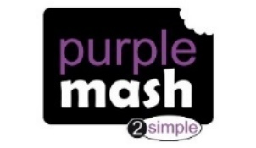 | https://www.purplemash.com/login/  Purple Mash hosts an exciting mash-up of curriculum focused activities. Work the teacher has set can be found on your child’s 2do Page.
Doodlemaths/  Doodletables | https://www.doodlemaths.com/ Also available on the APP Store.  Maths and Times tables Programs.  Work the teacher has set can be found on the ‘extras’ part of the Doodlemaths program.
SpellingShed | https://www.spellingshed.com/en-gb /  Also available on the APP Store Weekly spelling lists are uploaded on this program with activities to try to practise spelling these words.
Teach Your Monster to Read | https://www.teachyourmonstertoread.com/  Also available on the APP Store with age and phonics level appropriate games.
Phonics
Letters and Sounds
https://wandleenglishhub.org.uk/lettersandsounds/reception
On the link above there are daily Phonics lessons that your child can watch and join in with, they are going through each sound and upload a new video every day at 10am.
You can also watch lessons they have previously uploaded if you wanted to choose a specific lesson or sound!
These are extremely helpful lessons to help your child take part in daily phonics.

Class 1 Weekly Learning Tasks Week 8
Weekly Maths Tasks (Aim to do 1 per day) | Weekly Reading Tasks (Aim to do 1 per day)
Maths focus this week: Number Bonds to 10 and Addition  - Complete Maths activities on Purplemash  - Doodlemaths 5aday and Extras - your child has an individual login to access this.  - Practise your number bonds to 10 by making a Ten Frame and using counters or small objects at home in 2 different colours to work out which numbers add together to make 10. Write the number sentences for each number bond  - Addition – roll a dice or use a dice app to make your own number sentences but see if you can use your fingers or count in your head to count on to find the answer. 5+2= put 5 in your head and count on 2 fingers ...6...7!  - Chilli Challenge Addition – missing numbers in number sentences – Muddles the Giraffe has got very confused and is missing some numbers out of his addition number sentences, can you work out the ones that are missing so they make sense? Choose the page with the level you find is best for you! Or have a go at working up through them all (document attached to class page) | - Children to read to parents daily, reading a book on Bug Club. Complete the questions about the story on each page by clicking on the bugs face on the page.  - Read to your child, you could choose 2 books each day and your child can vote for which book they would like to have read to them. You could even have a whole family vote where everyone votes for the book they would like to hear and then count the votes to see which story has the most.  - Visit Oxford Owl for free eBooks that link to your child’s book band. You can create a free account at Oxford Owl ebook collection. Complete the linked Play activities for each book.  This weeks story:  Rapunzel  You can read the power point story that is in the document section on the Class page or if you have the story Rapunzel at home you could read that! There are many versions of this story as with all Fairy tales and Traditional tales so you could explore the differences between different versions if you have a different version to the power point one!
Weekly Phonics Tasks (Aim to do 1 per day) | Weekly Writing Tasks (Aim to do 1 per day)
- Daily Phonics – practise Sounds and Tricky words in Phonics Bag – this week teach your child how to read and write tricky word > ‘what’  - Phase 3 – Recap of all of Phase 3 digraphs – we will go over those tricky sounds just to refresh our memory and make sure we don’t forget them!  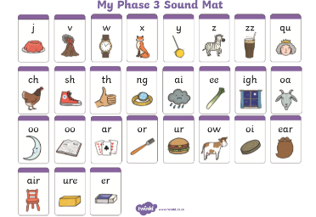  - Watch the videos of Geraldine Giraffe, where you can recap the sounds for this week. Choose one sound each day to look at, after the video can you write a list of words with that sound in them, you could go on your own hunt around the house.  qu - https://www.youtube.com/watch?v=mYGGk0MH_xQ  ch – https://www.youtube.com/watch?v=OyrYDitif1o  sh - https://www.youtube.com/watch?v=nx2Tf9TE1bc  th - https://www.youtube.com/watch?v=6U354eD-hgQ  - Write words with these sounds in, in a sentence. Don’t forget your capital letters and full stops – if you have practised some of our Phase 4 phonics over the past few weeks you can use these digraphs we are recapping in trickier words with the fast sounds at the start or end!  - Complete Education City activities  - Teach Your Monster to Read – log into your account to practise the sounds and ‘trickies’. | Fairytales  - Write the name of your favourite Fairy tale story, can you write the names of the characters in the story? Talk about if they are good or bad characters, are they kind or mean?  - Use the Fairy tale story telling dice game (added to documents on Class page). Roll a dice or use a dice app on a phone or tablet to select the Setting – Good and Bad Characters – and a prop that will be in your story. Can you discuss your story with your family, maybe you can make up and tell your ideas for the story!  - Chilli challenge – can you write down this story that you have created with the story telling dice game? Don’t forget to start your story with ‘Once upon a time’  Don’t forget capital letters, finger spaces and full stops!  - Rapunzel – complete the story board template (attached to the bottom of this document) for Rapunzel, can you write words or a sentence of what happened in each of the pictures of the story.  - Draw a picture of the witch from the story, can you write words around your picture to describe the witch!
Learning Project
to be completed throughout the week
The project this week aims to provide opportunities for your child to learn more about the topic Animals. Below there is a variety of tasks for you to complete throughout the course of the week, you can choose when you do each of these activities and you could even create some activities of your own to do with our topic.

- Use a cardboard box to create your own puppet theatre – make your favourite fairy tale characters as stick puppets or you could even create your own! Use your new puppet theatre and new stick puppets to act out your favourite story or create your own. You could record your show and watch it back or send it to your family and friends!
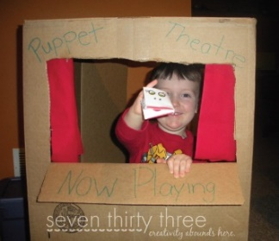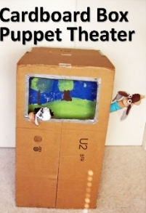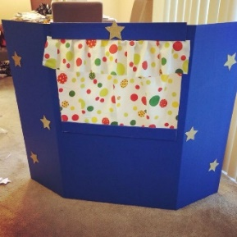
- Make tickets for your Puppet theatre show, how much will you charge for tickets? Can you make a poster for your story, this could have the title of your show and pictures of the characters or setting. This helps your customers to see what the show might be about! Don’t forget to put your name on the bottom, after all you are the creator of this show!

- Draw, paint, design your own Fairy tale character – you may have a costume at home you could copy as your design or you could use your imagination! Can you use different colours – mixing them together to create new colours! Maybe you could find different materials to create textures on your picture, how will you stick them down or join them?
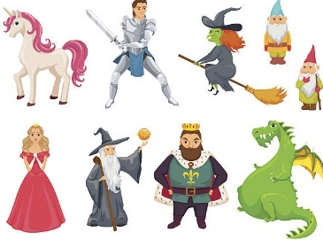
- Fairy tale nature bracelets – using masking tape, duct tape or Sellotape ask an adult to wrap a strip around your wrist so the sticky side is facing away from your skin. Go into your garden or go on a walk – find items in nature that you can attach to your bracelet (flowers, stems, leaves, grass, twigs, soil) Discuss why it is best to use items that have already fallen off plants rather than pulling them off plants! Have fun creating your Fairy tale bracelet – maybe each of your items you attach could mean something in a Fairy tale story!
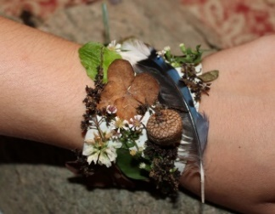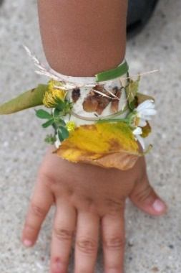

- Create your own Rapunzel tower using kitchen or toilet roll, you could design a pattern for the tower or the roof or even make yourself as the character stuck in the tower!
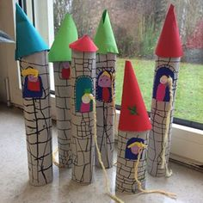

PE
- Joe Wicks Live PE Lessons each morning at 9 am.

- Go Noodle with the family or have a family workout.

- Cosmic Yoga videos are lots of fun!

- Can you create your own work out for your family? You could make an obstacle course in your house or in the garden, you could time each of your family members to see who completes it the fastest.
Useful Websites
- Oxford Owl for home - https://www.oxfordowl.co.uk/
Providing free access to online books for parents

- Twinkl – https://www.twinkl.co.uk/
Providing free access to home learning packs

- Phonics Play – https://www.phonicsplay.co.uk/
A fantastic website for your child to independently access phonics games where you can select specific sounds or tricky words to focus on. Currently providing a free login in march to access from home.

- Story Online – https://www.storylineonline.net/
Access to a wide variety of books read aloud for your child to listen to

- Vooks - https://www.vooks.com/
Access to a wide variety of books – currently free

- Sky Writer - https://www.ictgames.com/mobilePage/skyWriter/index.html
Cursive hand-writing practice

- Phonics Bloom - https://www.phonicsbloom.com/

- BBC Supermovers - https://www.bbc.co.uk/teach/supermovers

- Topmarks - https://www.topmarks.co.uk/Search.aspx?Subject=37
A website full of interactive games

- ICT Games - http://www.ictgames.com/
A website full of interactive games

-Lalilo - https://www.lalilo.com/
This site is completely free to sign up to and use at the moment. It is full of Phonics and Reading games that you can use with your child.
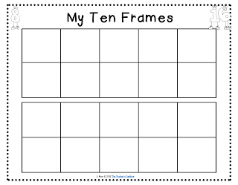Rapunzel Story Board 