ANSON PRIMARY SCHOOL
Class 1 – Week 9
Weekly Learning Tasks
Why have Weekly Learning Tasks been created?
Weekly learning tasks have been created as a result of the ongoing risk of schools shutting due to the Coronavirus outbreak across the UK. Based on this very real and increasing threat. Class teachers have therefore written a set of weekly learning tasks which can be completed by your child whilst schools are closed for a set duration. In creating the weekly learning tasks we fully acknowledge that they cannot replace the quality of learning your child receives at school however, our complete focus has been on creating a set of tasks that all children can access to maximise their learning whilst at home.
What are the aims of the Weekly Learning Tasks?
- To create age specific learning opportunities for primary school children.
- To create a resource for parents that is easy to access and use - the focus is on parents being able to help deliver the content or children accessing it independently.
- Key learning is linked to the Early Years Foundation Stage.
- To enable children to continue with their learning at home during an enforced shutdown.
- To provide structure and focus to each day when an enforced shutdown occurs.
- To centralise online learning resources and links into an easy to manage format for families.
How do I use the Learning Tasks?
As a parent your first step is to read the ideas outlined in this document and choose 1 task from each area to do that day, there is no set time that you should spend on each task as you may wish for your child to spend less or more time on activities.

A mailbox has been set up to receive emails only for any work set outside of the educational programs we use. Please feel free to send work, photographs to your class teacher using the following email address is: anson.class1@tssmat.staffs.sch.uk
We are unable to reply to any emails sent to this address.
If you wish to contact the class teacher please do so as usual by emailing the office email address. anson.office@tssmat.staffs.sch.uk. The class teacher will make every effort to respond within 2 working days.

Online Programs
(Logins for these programs found in the front of your child’s homework diaries)
Bug Club  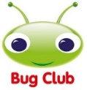 | https://www.activelearnprimary.co.uk/login?c=0  Differentiated Reading Books, which asks your child questions about the texts.
Education City | https://www.educationcity.com/  Age appropriate Literacy and Numeracy Games  Games the teacher has set will be found on your child’s MyCity Page.  We encourage a score of 80% or more, to ‘Pass’ the game.
Purple Mash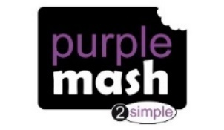 | https://www.purplemash.com/login/  Purple Mash hosts an exciting mash-up of curriculum focused activities. Work the teacher has set can be found on your child’s 2do Page.
Doodlemaths/  Doodletables | https://www.doodlemaths.com/ Also available on the APP Store.  Maths and Times tables Programs.  Work the teacher has set can be found on the ‘extras’ part of the Doodlemaths program.
SpellingShed | https://www.spellingshed.com/en-gb /  Also available on the APP Store Weekly spelling lists are uploaded on this program with activities to try to practise spelling these words.
Teach Your Monster to Read | https://www.teachyourmonstertoread.com/  Also available on the APP Store with age and phonics level appropriate games.
Phonics
Letters and Sounds
https://wandleenglishhub.org.uk/lettersandsounds/reception
On the link above there are daily Phonics lessons that your child can watch and join in with, they are going through each sound and upload a new video every day at 10am.
You can also watch lessons they have previously uploaded if you wanted to choose a specific lesson or sound!
These are extremely helpful lessons to help your child take part in daily phonics.

Class 1 Weekly Learning Tasks Week 9
Weekly Maths Tasks (Aim to do 1 per day) | Weekly Reading Tasks (Aim to do 1 per day)
Maths focus this week: Subtraction  - Complete Maths activities on Education City  - Doodlemaths 5aday and Extras - your child has an individual login to access this.  - Make 2 sets of number cards on paper – one set of low numbers and one set of higher numbers. (you can choose how high or low your numbers are to make this at the best level for you) spread them out upside down in two groups in high and a low numbers, turn them over to create a subtraction number sentence. Make sure the higher number is first and you are taking away the smaller number.  - Make your own number line from 0-10 (or higher if you want an extra challenge) draw lines for each number and label. Use the subtraction number sentences to ‘act out’ your subtraction on the line by counting back, drawing jumps backwards on your number line.  - Complete the subtraction number line work, attached to the bottom of this document. Try counting back, using jumps, your fingers, or counters. Your answer is how many if left. If you want an extra challenge, then make the numbers bigger!  - Complete the subtraction bus game, attached to Class 1’s webpage. You can play this as a family, but you must answer the question correctly to stay on the space you’ve moved to otherwise you have to go back! Have some counters/objects nearby to help with the questions! | - Children to read to parents daily, reading a book on Bug Club. Complete the questions about the story on each page by clicking on the bugs face on the page.  - Read to your child, you could choose 2 books each day and your child can vote for which book they would like to have read to them. You could even have a whole family vote where everyone votes for the book they would like to hear and then count the votes to see which story has the most.  - Visit Oxford Owl for free eBooks that link to your child’s book band. You can create a free account at Oxford Owl ebook collection. Complete the linked Play activities for each book.  This weeks story:  The Three Little Pigs  I bet you know this story! This story is a Traditional Tale and is very well known! Hopefully you will be able to join in as you read this story. We will be learning the Talk 4 Writing actions too so you can teach yourself these and be able to re-tell the story by yourself! You can watch the Animation story or the ebook (both attached to the Class 1 webpage)
Weekly Phonics Tasks (Aim to do 1 per day) | Weekly Writing Tasks (Aim to do 1 per day)
- Daily Phonics – practise Sounds and Tricky words in Phonics Bag – this week teach your child how to read and write tricky word  > ‘when’  - Watch the videos below each day to recap over a Phase 3 sound, Choose only one sound each day to look at, after the video can you write a list of words with that sound in them.  ai-https://www.youtube.com/watch?v=siVkXoEQDNc&feature=youtu.be  ee– https://www.youtube.com/watch?v=hBFFUCraDt8&feature=youtu.be  igh - https://www.youtube.com/watch?v=7anrdHnwGbs&feature=youtu.be  oa – https://www.youtube.com/watch?v=rrGadCz2A1o&feature=youtu.be  - Write words with these sounds in, in a sentence. Don’t forget your capital letters and full stops – if you have practised some of our Phase 4 phonics over the past few weeks you can use these digraphs we are recapping in trickier words with the fast sounds at the start or end!  - Complete Education City phonics activities  - Teach Your Monster to Read – log into your account to practise the sounds and ‘trickies’. | 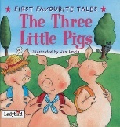  The Three Little Pigs  - After reading the story, create your own story map (attached to the bottom of this document) for The Three Little Pigs with the main parts of the story, this will help you to remember what happens in the story and help you when you re-tell the story!  - Write a sentence for each of the houses that the Little Pigs made, you could describe what they look like or if they are strong or not. Try and use a tricky word in your sentence!  - Draw a picture of one of the Little Pigs and label his features and clothes.  - Design your own house – what would you make if you were to build your own house, write a list of materials you would need. How would you make it strong enough so the wolf couldn’t blow it down?
Learning Project
to be completed throughout the week
There is a variety of tasks for you to complete throughout the course of the week, you can choose when you do each of these activities and you could even create some activities of your own to do with our topic.

- Make your own Three Little Pigs small world, you have been fantastic at making these for our different stories, so I can’t wait to see the one you create for this one!
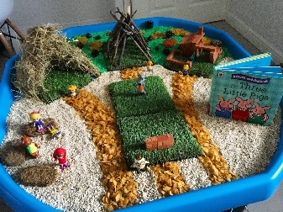
- Build your own version or the Three Little Pigs houses, you could use straw, sticks or bricks like in the story or you could create your own model using what you have at home! Have fun planning and designing your model. Don’t forget to build it strong enough so the wolf won’t be able to blow it down!
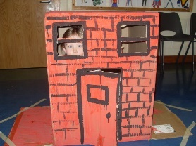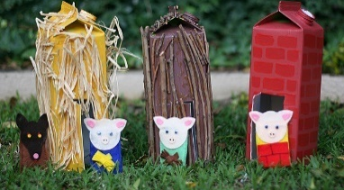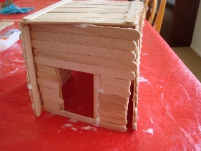
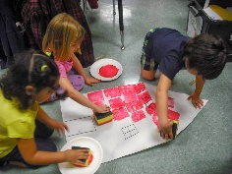
- You could even find out about how houses are built, and why the brick house was the strongest and didn’t blow down! You could use a sponge to create the bricks on your big brick house and see how they need to cross over to be strong!

Look at your house, how has your house been built? How many rooms does it have? What kind of doors or windows does it have? Do you have any rooms like a loft or a garage? Do you have a house attached to your house or is it on its own? Talk about this with your family about the names for these different types of houses!
Do you know what number your house is or what your road/street is called where you live? That might be useful to know!
Compare your house to your neighbour’s house, do they look the same, what’s different?
Compare your house to a family members house, talk about the similarities and differences.

- Create your own Three Little Pigs masks and a wolf mask, or your own pigs snout! You and your family could act out the story holding your masks, you can use the voice you think your pig makes when you are acting! I think the wolf would have a deep, scary voice!
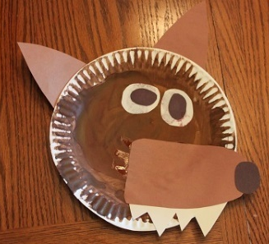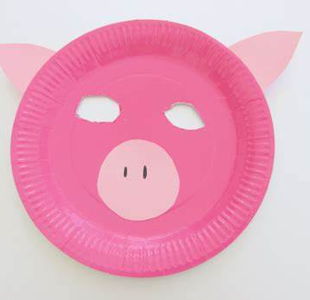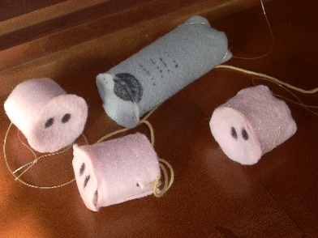
- Have a go at some baking! Follow a simple cupcake recipe and try to create pig cupcakes, you could even add pink food colouring to your cake mixture to make your cakes pink inside! Help to make a list, find out how much of each and measure the ingredients you will need. Enjoy decorating them!
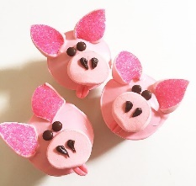

PE
- Joe Wicks Live PE Lessons each morning at 9 am.

- Go Noodle with the family or have a family workout.

- Cosmic Yoga videos are lots of fun!

- Can you create your own work out for your family? You could make an obstacle course in your house or in the garden, you could time each of your family members to see who completes it the fastest.
Useful Websites
- Oxford Owl for home - https://www.oxfordowl.co.uk/
Providing free access to online books for parents

- Twinkl – https://www.twinkl.co.uk/
Providing free access to home learning packs

- Phonics Play – https://www.phonicsplay.co.uk/
A fantastic website for your child to independently access phonics games where you can select specific sounds or tricky words to focus on. Currently providing a free login in march to access from home.

- Story Online – https://www.storylineonline.net/
Access to a wide variety of books read aloud for your child to listen to

- Vooks - https://www.vooks.com/
Access to a wide variety of books – currently free

- Sky Writer - https://www.ictgames.com/mobilePage/skyWriter/index.html
Cursive hand-writing practice

- Phonics Bloom - https://www.phonicsbloom.com/

- BBC Supermovers - https://www.bbc.co.uk/teach/supermovers

- Topmarks - https://www.topmarks.co.uk/Search.aspx?Subject=37
A website full of interactive games

- ICT Games - http://www.ictgames.com/
A website full of interactive games

-Lalilo - https://www.lalilo.com/
This site is completely free to sign up to and use at the moment. It is full of Phonics and Reading games that you can use with your child.
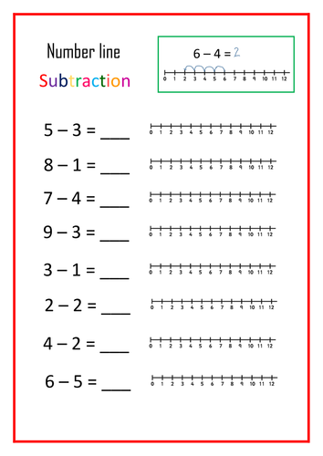

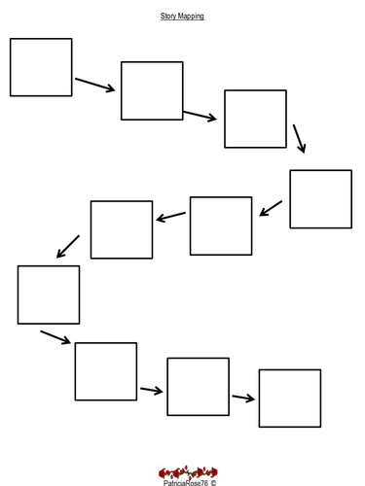
The Three Little Pigs – Story Map

