ANSON PRIMARY SCHOOL
Class 2 – Week 3
Weekly Learning Tasks
There are lots of hyperlinks in this document. To activate the links, which are in dark blue text, press ‘ctrl’ and then click the blue link.
Why have Weekly Learning Tasks been created?
Weekly learning tasks have been created as a result of the ongoing risk of schools shutting due to the Coronavirus outbreak across the UK. Based on this very real and increasing threat. Class teachers have therefore written a set of weekly learning tasks which can be completed by your child whilst schools are closed for a set duration. In creating the weekly learning tasks we fully acknowledge that they cannot replace the quality of learning your child receives at school however, our complete focus has been on creating a set of tasks that all children can access to maximise their learning whilst at home.
What are the aims of the Weekly Learning Tasks?
- To create age specific learning opportunities for primary school children.
- To create a resource for parents that is easy to access and use - the focus is on parents being able to help deliver the content or children accessing it independently.
- Key learning is linked to the National Curriculum.
- To enable children to continue with their learning at home during an enforced shutdown.
- To provide structure and focus to each day when an enforced shutdown occurs.
- To centralise online learning resources and links into an easy to manage format for families.
How do I use the Learning Tasks?
As a parent your first step read the ideas outlined in this document. There is no set time that you should spend on each time but a suggested timetable has been created to help. However it is very much your parental choice how you structure your day and you may wish for your child to spend less or more time on activities.
A mailbox has been set up to receive emails only for any work set outside of the educational programs we use. Please feel free to send work, photographs to your class teacher using the following email address is: anson.class2@tssmat.staffs.sch.uk
We are unable to reply to any emails sent to this address.
If you wish to contact the class teacher please do so as usual by emailing the office email address. anson.office@tssmat.staffs.sch.uk. The class teacher will make every effort to respond within 2 working days.
A Suggested Timetable (Just a guide to how a typical day may run).
 | Monday | Tuesday | Wednesday | Thursday | Friday
30 Minutes | PE | PE | PE | PE | PE
1 Hour | Maths | Maths | Maths | Maths | Maths
1 Hour | English & Spelling Test | English | English | English | English
30 Minutes | Reading | Reading | Reading | Reading | Reading
1 Hour | RE | Computing | Topic | Science | Art
20 Minutes | Phonics/ Grammar | French | Phonics/ Grammar | Music | Phonics/ Grammar

What happens if my child finds the learning too difficult? Our first piece of advice to parents is that ALL children find elements of learning challenging at times so try not to worry if your child becomes stuck and you cannot explain it to them. If this happens then make a note of what they found hard and move onto another learning activity – the school will try their best to cover any misconceptions when we return.
My child is on the SEN register, how can I help? It could also be that learning time at home is used to work on the targets which your child is currently on. These targets were shared with you on their Anson Education Plan at the last termly meeting. In preparation for a potential closure, the school SENCo/Support Team gave some children additional work they can access, if some of the weekly work is too difficult.
Weekly Learning Tasks
Class 2 – Year 1 & 2
Online Programs
(Logins for these programs found in the front of your child’s reading diaries)
Bug Club | https://www.activelearnprimary.co.uk/login?c=0  Differentiated Reading Books, which asks your child questions about the texts.
Education City | https://www.educationcity.com/  Age appropriate Literacy and Numeracy Games  Games the teacher has set will be found on your child’s MyCity Page.  We encourage a score of 80% or more, to ‘Pass’ the game.
Purple Mash | https://www.purplemash.com/login/  Purple Mash hosts an exciting mash-up of curriculum focused activities. Work the teacher has set can be found on your child’s 2do Page.
Doodlemaths/  Doodletables | https://www.doodlemaths.com/ Also available on the APP Store.  Maths and Times tables Programs.  Work the teacher has set can be found on the ‘extras’ part of the Doodlemaths program.
SpellingShed | https://www.spellingshed.com/en-gb /  Also available on the APP Store Weekly spelling lists are uploaded on this program with activities to try to practise spelling these words.
Teach your monster to read (Year 1 only) | https://www.teachyourmonstertoread.com/  The app is free to download. Please see the letter and login in your child’s reading diaries.
Weekly Maths Tasks
- Complete the fraction activities- aim to complete one interactive activity and the matching activity sheet per day.
Education City – My City – Week 3 Maths.

- Can you create different shapes using paper and divide it into fractions? Can you shade 2/4 of the shape? Can you shade ¾ of the shape?

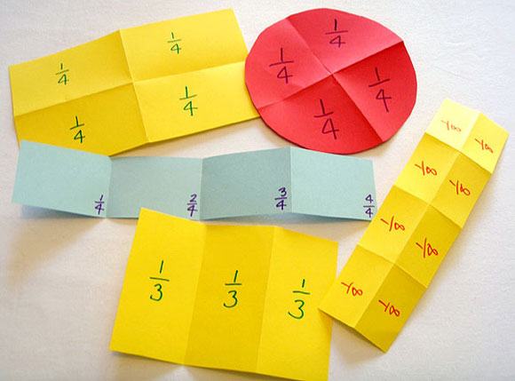

- You could do the same using food/ different objects around the house. Can you cut the pizza into half? Can you give half of your chocolate bar to your Mummy or Daddy? Can you divide your toys into quarters?

- Doodle Maths – Access your ‘Extras’.

- Doodle Maths – Challenge yourself to complete ‘5/6 a day’.

- Doodle Tables – Practise 2, 5 and 10 times tables.

- Practise counting in 2s, 5s and 10s.

- Play on Hit the Button - focus on number bonds, halves, doubles and halves.

Weekly English Tasks
- 3 English games per year group are on Education City for you to access- aim to do one per day.

Education City – My City – Week 3 - English.

- Complete an English Supermover.
Supermovers

- Listen to the story of Oh no George! on Youtube.

- Activity 1- write a recount of what activities they did at home in their Easter holiday e.g. baked a cake, played outside, drew a picture. Remember to write in the past tense.

- Year 1 to write at least 3 sentences with a capital letter and full stop about their holiday.

- Year 2 to include time connectives (first, then, next) and write at least 7 sentences with correct punctuation about their holiday.

- Activity 2- Children choose a picture of George doing something bad in the book. They look at it and think about what they would say to George. Then they draw themselves shouting at George. What might they say? They use an exclamation mark (see resources at the end of this document pages 10-12).

- Year 1 to include: capital letters, full stops, finger spaces and an exclamation mark.

Challenge: Next add a reply from George.

- Year 2 to include: exclamation marks and inverted commas to show speech.

Challenge: Children write a conversation between themselves and George, having a go at using inverted commas and exclamation marks.

Write these on a word document and email them to Class 2 email. Check the website to see if it makes the ‘Hall of Fame’.

Use your best cursive handwriting to write your questions down and email to Class 2 email.

Weekly Reading Tasks | Weekly Spelling/ phonics Tasks
- Purple Mash – Access your ‘To Dos’. Read chapter 1 of the book I have set you, then try the multiple choice quiz, which asks you questions about the chapter you have read.  (Both chapter 1 and the multiple choice quiz can be found on your ‘ToDo’s).  - Get your child to read a book on Active learn and complete the activities. They will practise their comprehension skills. Encourage them to refer back to the text.  - You could share a story together. Ask your child comprehension questions about the story. What do you think will happen next? What has happened in the story so far? Who are the main characters? Re- tell the story.  - Listen to your child read and let them discuss what they have read. Encourage them to read with expression and fluency.  - Explore new vocabulary you find when reading.  - Listen to an audio book each day read by David Walliams. Discuss the story after and ask the children questions about it.  Audio book | - Test your child’s weekly spellings every Monday. (Their latest spelling list can be found on the class page)  - Practise your spellings on Spelling Shed.  - Spelling City.  - Daily phonics – your child to practice their sounds and blend words. Interactive games found on link below.  https://www.phonicsplay.co.uk/#  - Year 1 Phonics- aim to complete one activity per day.  Education City – My City – Week 3 – Phonics  - Year 2 Grammar- aim to complete one activity per day.  Education City – My City – Week 3 – Grammar  - Got a nerf gun? Focus on a particular phonics words/ sounds or weekly spellings (Year 1). Focus on ks1 statutory spelling list or weekly spellings (Year 2) – Stick answers on post it notes on the wall. Test your child by asking them questions and they have to ‘fire’ at the answer. Haven’t got a nerf gun? Don’t worry just ask them to tap the answer, like a speed reaction game.  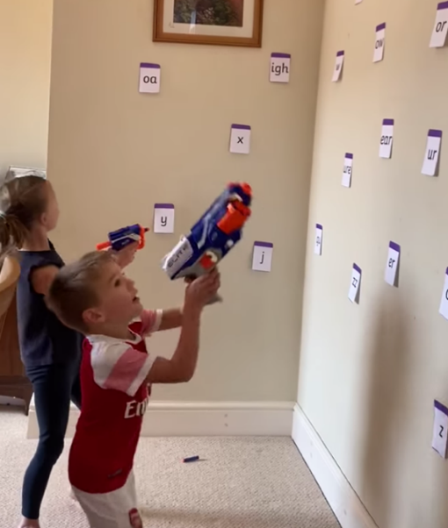
RE | Computing
- Watch the video on Pentecost  and talk about how the Holy Sprit gives us power, wisdom and peace. Ask your child to think about what the Holy Spirit helps them to do. Write a prayer to God thanking him for it. | - 2DO – Purple Mash – Use ‘2Connect’ on your 2Dos.  - Create a concept map in 2Connect on transport (see the example below).
Topic – Toys Past and Present | Design and Technology/ Art
Please email the completed tasks to Class 2 email.  - Describe your favourite toy.  Purple Mash- 2Dos- Week 3 Topic- Describing toys (writing project).  - Can you create your own timeline of when toys were invented/ introduced? (find the enlarged versions of the worksheets below at the bottom of this document pages 13-15).  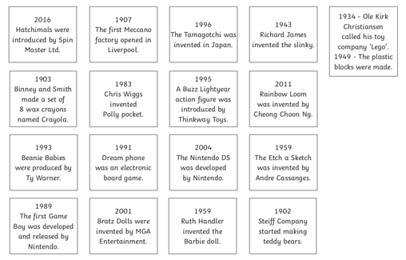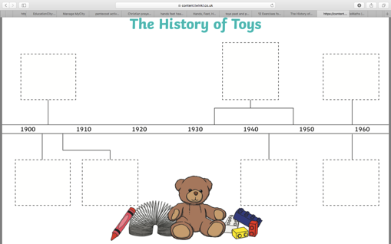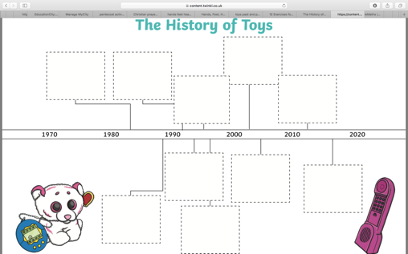 | Design a toy from the past on Purple Mash.  Purple Mash- 2Dos- Week 3 Art- 2Paint A Picture.  Create some flowers to display in your window to ‘spread some joy’. See how many flowers you can spot in people’s windows.  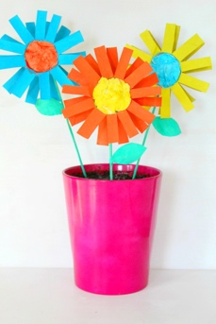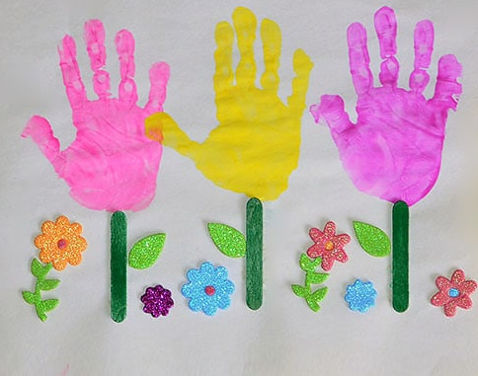
Science – Plants | French
Please email the completed tasks to Class 2 email.  - Complete the plants activities on Purple Mash.  Purple Mash – 2Dos – Week 3- Science- plant labelling.  Purple Mash – 2Dos – Week 3- Science- growing plants (writing project).  - Can you grow your own plant from a seed?  Keep a weekly diary of how your plant is growing.  Purple Mash – 2Dos – Week 3- Science- plant diary. | Can you find the French words for brother and sister?
Music | PE
- Watch the YouTube link of the children singing ‘Hands, feet and heart’. Join in yourself using the lyrics below. Can you use musical instruments to accompany it?  Hands, feet and heart.  Feeling confident? Get a family member to video you, and watch yourself back. What did you do well? How could you improve?  In my hands, in my feet, in my heart,  Music is in me,  In my hands, in my feet, in my heart,  Music is in me.  In my soul (in my soul)  In my heart (in my heart)  Music is in me,  In my soul (in my soul)  In my heart (in my heart)  Music is in me.  In my hands, in my feet, in my heart,  Music is in me,  In my hands, in my feet, in my heart,  Music is in me.  In my soul (in my soul)  In my heart (in my heart)  Music is in me,  In my soul (in my soul)  In my heart (in my heart)  Music is in me.  Music is in me,  Music is in me. | - Try one of Joe Wicks Live PE Lessons each morning at 9 am.  - Go Noodle with the family or have a family workout.  - Fancy a dance? There are lots of dance videos they could try. Dance.  - Maybe try some Yoga.  - Can you create your own circuit workout to do with your family?
Additional Activities/ Useful websites
- Practise the Year 1/2 common exception words (in your homework folder).

- Watch Newsround and discuss what is happening in the wider world.

- Use some of the educational programs outlined at the top of this documents for further learning .

- Time to Talk: Perhaps play a board game, facetime a member of their family they have not seen this week, enjoy a family indoor picnic or have a family dinner.

- https://www.phonicsplay.co.uk/#

- https://www.twinkl.co.uk/

- https://www.bbc.co.uk/bitesize/levels/z3g4d2p

- Supermovers

