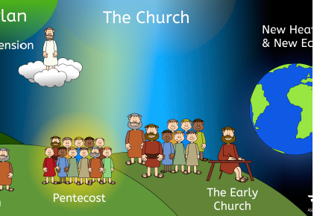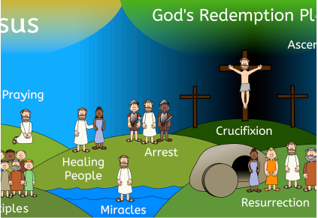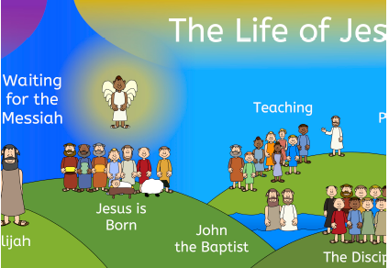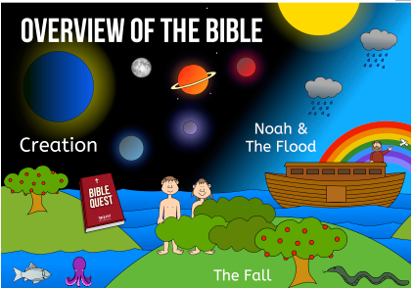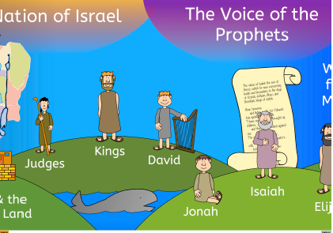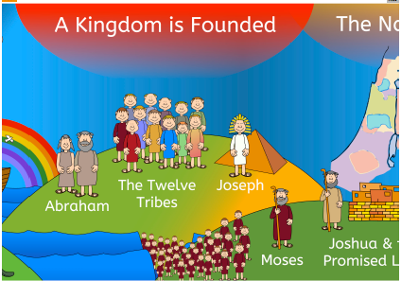

**Where are we on our timeline of the Bible?**

**Deeper Thinking   
Questions**

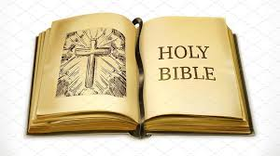

**Christians praise and worship God**

**Stories are used to show some of these beliefs about God**

**Christians believe God is Lord and King**

**Christians believe God is loving, kind, fair and forgiving**

**Christians find out about God in the Bible**

**Christians believe in God**

**Outcomes**

· Identify what a parable is

· Tell the story of the Lost Son

· Explain what the story means to Christians

· Give two examples of a way in which Christians show their belief in God as loving and giving

· Give an example of beliefs into practice in worship

· Can anything be learned from the story?

**Key Vocabulary**

**belief**

Something that is true

**parable**

Short story to teach a lesson

**fair**

Treat everyone equally

Does not take sides

**forgive**

Let go of anger against someone

**worship**

Show love and praise God

**KS1 – Unit 1.1 God**

**What do Christians believe God is like?**



**God offers forgiveness even when his people keep falling short.**

**Humans cannot get close to God without God’s help.**

**The Bible shows that God wants to help people to be close to him -he keeps his relationship with them.**

**The Bible tells a story (in Genesis 3) about how humans spoiled their friendship with God (the fall).**

**KS1 – Unit 1.2 - Creation**

**Who made the world?**

**God the Creator cares for the creation, including human beings.**

**Key Vocabulary**

**Creation**

Causing something to exist

**Creator**

The maker; God

**Human**

A person

**The Fall**

The breakdown of the relationship between God and his people.

**Genesis**

The first book of the Bible

Outcomes

· Retell the story of creation from Genesis 1:1–2.3 simply.

Recognise that ‘Creation’ is the beginning of the ‘big story’ of the Bible.

Say what the story tells Christians about God, Creation and the world.

Give at least one example of what Christians do to say thank you to God for the Creation.

Think, talk and ask questions about living in an amazing world.

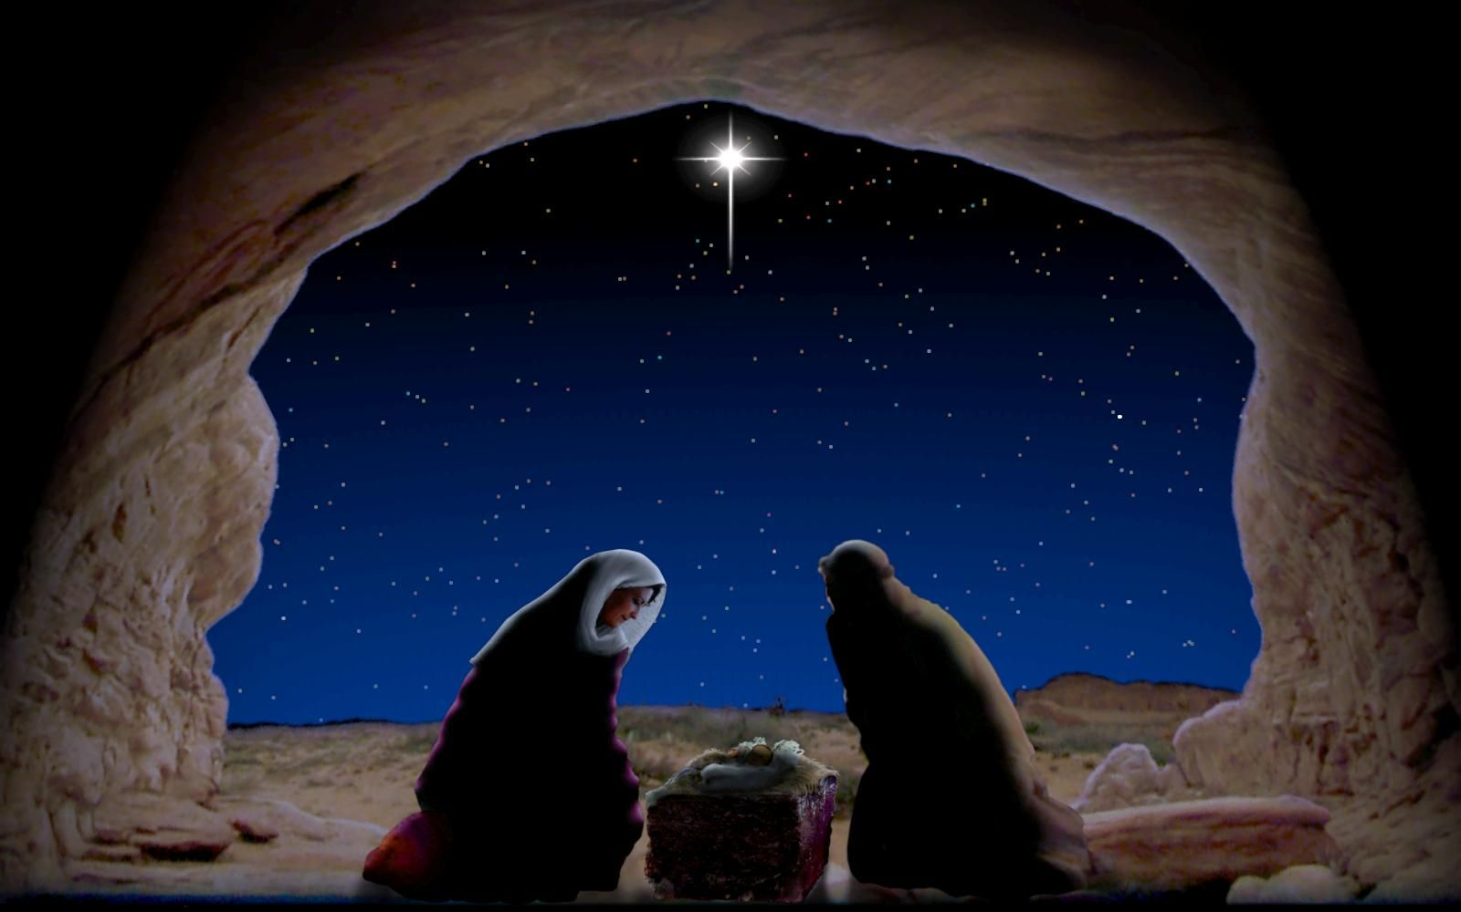

**Jesus was born in Bethlehem.**

**Christians believe that Jesus is God and that he was born as a baby.**

**Key Vocabulary**

**Incarnation**

God in human form

God in the flesh

**Christmas**

A special day when Christians remember and celebrate Jesus’ birth

**Mary**

Jesus’ mother

**Joseph**

Jesus’ father on Earth

**Advent**

The four weeks before Christmas

**Gospel**

The teaching of Christ

**Christmas is a time when Christians celebrate Jesus’ birth.**

**Advent is when Christians get ready for Jesus.**

**Outcomes**

• Give a clear, simple account of Jesus’ birth

· Recognise that stories about Jesus’ life come from the Gospels

· Give examples of the ways in which Christians use the story of the nativity to guide their beliefs and actions at Christmas

· Decide what they have to be thankful for at Christmas

**KS1 – Unit 1.3 – Incarnation**

**Why does Christmas matter to Christians?**

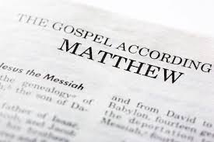

**Christians believe Jesus’ teachings make people think hard about how to live and show them the right way.**

**.**

**For Christians, this good news involves being loved by God and forgiven for bad things.**

**.**

**Christians believe Jesus is a friend to the poor and friendless.**

**.**

**Christians believe Jesus brings good news for all people.**

**Key Vocabulary**

**Gospel**

The books of the Bible which are about Jesus’ life.

**Belief**

Something that is true.

**Peace**

freedom; quiet, calm

**Forgive**

Let go of anger against someone.

**Confession**

Say you have done things bad things or made the wrong choices.

**Disciples**

Follower of Jesus

**Outcomes**

· Tell stories from the Bible and link with ‘Gospel’ or good news.

· Explain what Bible texts mean to Christians.

· Recognise that Jesus gives instructions about how to behave.

· Give two examples of how Christians bring good news to their communities.

· Think, talk and ask questions about whether Jesus’ goodnews is just for Christians or if there are things for anyone to learn.

**KS1 – Unit 1.4 – Gospel**

**What is the good news Jesus brings?**

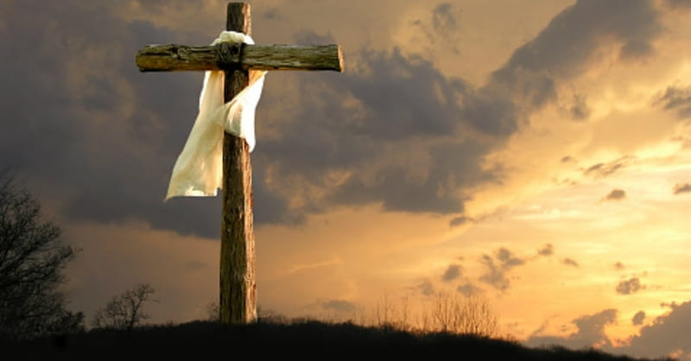

**KS1 – Unit 1.5 – Salvation**

**Why does Easter matter to Christians?**

**Christians believe Jesus’ resurrection gives people hope of a new life.**

**Christians believe that after three days Jesus came back to life.**

**Christians believe Jesus died on a cross.**

**Easter is a very important part in the ‘big story’ of the Bible.**

**Outcomes**

• · Recognise that Incarnation and Salvation are part of a ‘big story’ of the Bible.

· Tell stories of Holy Week and Easter.

· Recognise that Jesus gives instructions about how to live.

· Give at least three examples of how Christians show their beliefs at Easter.

· Think, talk and ask questions about whether the story of Easter has anything to say about sadness, hope or heaven.

**Key Vocabulary**

**Incarnation**

God in human form

God in the flesh

**Salvation**

Jesus rescuing people

**Crucifixion**

being killed by being nailed to a cross

**Resurrection**

coming back alive

**Easter**

Festival when Christians celebrate Jesus resurrection

**Holy Week**

The week leading up to Easter including Palm Sunday and Good Friday

**Betrayal**