

**Christians believe God loves people so much that Jesus was born, lived, was crucified and rose again to show God’s love**

**Christians believe God is both holy and loving, and Christians have to balance ideas of God being angered by sin and injustice (see Fall) but also loving, forgiving, and full of grace**

**Christians believe God is omnipotent, omniscient and eternal, and that this means God is worth worshipping.**

**Outcomes**

Identify some different types of biblical texts, using technical terms accurately.

Explain connections between biblical texts and Christian ideas of God, using theological terms.

Make clear connections between Bible texts studied and what Christians believe about God; for example, through how churches are designed.

Show how Christians put their beliefs into practice in worship.

Weigh up how biblical ideas and teachings about God as holy and loving might make a difference in the world today, developing insights of their own.

**Key Vocabulary**

**Omnipotent**

God is all-powerful

**Omniscient**

God knows all things

**Eternal**

God created time and is not limited by it — God is outside time: God does not get old like human beings

**Holy**

God is morally pure and hates sin ― God is separate from human beings, who are sinful

**Loving**

God wants the very best for human beings, and does a lot to care for them.

**Spirit**

God is not physical ― God does not have a body

**Sin**

transgress those boundaries God has set for us

**Holiness**

The state of being holy

**Confession**

Being transparent and honest before God.

**Reconciliation**

Bridging of the gap between God and humans caused by original sin

**Upper Key Stage 2 – Unit 2b.1 – God**

**What does it mean if God is holy and loving?**



**The discoveries of science make Christians wonder even more about the power and majesty of the Creator**

**These debates and controversies relate to the purpose and interpretation of the texts. For example, does reading Genesis as a poetic account conflict with scientific accounts?**

**There is much debate and some controversy around the relationship between the accounts of creation in Genesis and contemporary scientific accounts**

**Key Vocabulary**

**Creation**

Causing something to exist

**Creator**

The maker; God

**Human**

A person

**The Fall**

The breakdown of the relationship between God and his people.

**Genesis**

The first book of the Bible

**Stewards**

Stewardship is a theological belief that humans are responsible for taking care of the world

**Cosmology**

the science of the origin and development of the universe

**Outcomes**

Outline the importance of Creation on the timeline of the ‘big story’ of the Bible.

Identify what type of text some Christians say Genesis 1 is, and its purpose.

Taking account of the context, suggest what Genesis 1 might mean, and compare their ideas with ways in which Christians interpret it, showing awareness of different interpretations.

Make clear connections between Genesis 1 and Christian belief about God as Creator.

Show understanding of why many Christians find science and faith go together.

Identify key ideas arising from their study of Genesis 1 and comment on how far these are helpful or inspiring, justifying their responses.

Weigh up how far the Genesis 1 creation narrative is in conflict, or is complementary, with a scientific account.

**Upper Key Stage2 – Unit 2b.2 – Creation / Fall Creation and Science: Conflicting or complimentary**

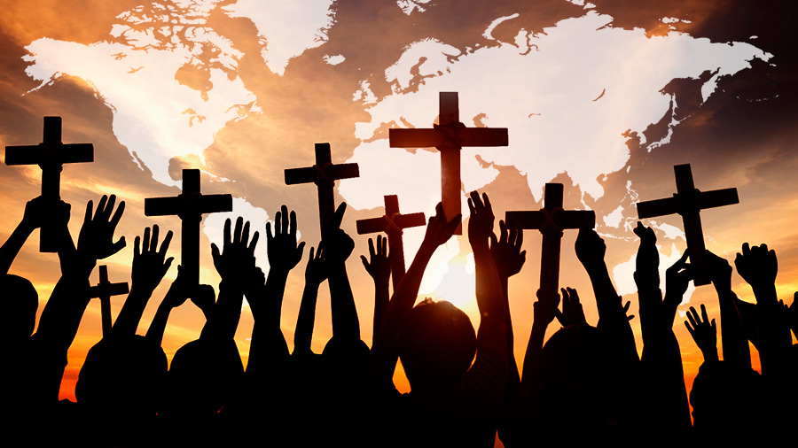

**Christians apply this idea to living today by trying to serve God and to bring freedom to others; for example, loving others, caring for them, bringing health, food, justice, and telling the story of Jesus**

**The story of Moses and the Exodus shows how God rescued his people from slavery in Egypt; Christians see this story as looking forward to how Jesus’ death and resurrection also rescue people from slavery to sin**

**The Old Testament pieces together the story of the People of God.**

**Key Vocabulary**

**Covenant**

Promises made by two people to each other

**Command**

Being told to do something

**Promise**

Saying you will do something.

**Freedom**

the state of not being imprisoned or enslaved

Justice

just behaviour or treatment

**Old Testament**

the first part of the Christian Bible

**Exodus**

the departure of the Israelites from Egypt

**Plague**

An incident of affliction or disease

**Moses**

One of God’s prophets

**Promised Land**

A land promised by God

**Outcomes**

Explain connections between the story of Moses and the concepts of freedom and salvation, using theological terms.

Make clear connections between Bible texts studied and what Christians believe about being the People of God and how they should behave.

Explain ways in which some Christians put their beliefs into practice by trying to bring freedom to others.

Identify ideas about freedom and justice arising from their study of Bible texts and comment on how far these are helpful or inspiring, justifying their responses.

**Upper Key Stage 2 – Unit 2b.3 – People of God – How can following God bring freedom and justice?**

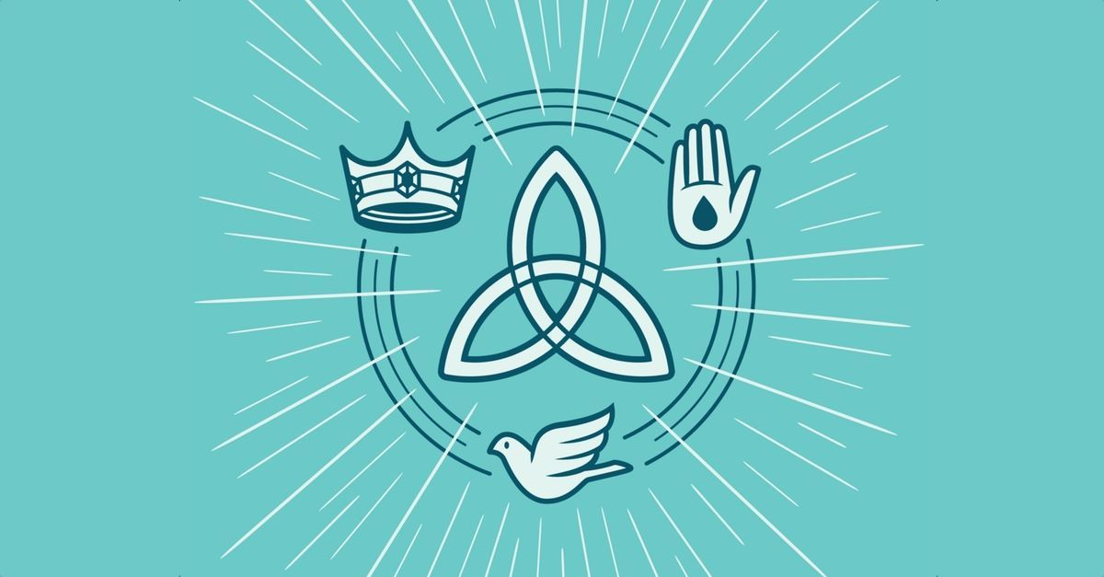

**Key Vocabulary**

**Incarnation**

God in human form

God in the flesh

**Trinity**

The three persons in one God.

Father, Son, Holy Spirit

**Baptism**

Welcome into the Christian church using water

**Immersal**

Dip the whole body in water for baptism**.**

**Gospel**

The books of the Bible which are about Jesus’ life.

**Messiah**

the promised deliverer of the Jewish nation prophesied in the Hebrew Bible

**Prophet**

a person chosen to speak for God

**Saviour**

One who saves from any form or degree of evil

**Exile**

the state or a period of forced absence from one's country **or home**

**Upper Key Stage 2 – Unit 2b.4 – Incarnation – Was Jesus the Messiah?**

**Christians believe God is Trinity: Father, Son and Holy Spirit.**

**Outcomes**

Explain the place of Incarnation and Messiah within the ‘big story’ of the Bible.

Identify Gospel and prophecy texts, using technical terms.

Explain connections between biblical texts, Incarnation and Messiah, using theological terms.

Show how Christians put their beliefs about Jesus’ Incarnation into practice in different ways in celebrating Christmas.

Comment on how the idea that Jesus is the Messiah makes sense in the wider story of the Bible.

Weigh up how far the idea that Jesus is the Messiah — a Saviour from God — is important in the world today and, if it is true, what difference that might make in people’s lives

**Christians believe Jesus is God in the flesh**

**They believe that his birth, life, death and resurrection were part of a longer plan by God to restore the relationship between humans and God.**

**The Old Testament talks about a ‘rescuer’ or ‘anointed one’ — a messiah. Some texts talk about what this ‘messiah’ would be like**

**• Christians believe that Jesus fulfilled these expectations, and that he is• Christians see Jesus as their Saviour the Messiah.**

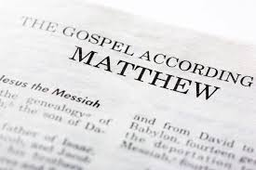

**• Christians believe that they should bring this good news to life in the world in different ways, within their church family, in their personal lives, with family, with their neighbours, in the local, national and global community.**

**Christians see that Jesus’ teachings and example cut across expectations — the Sermon on the Mount is an example of this, where Jesus’ values favour serving the weak and vulnerable, not making people comfortable.**

**The good news is not just about setting an example for good behaviour and challenging bad behaviour: it is that Jesus offers a way to heal the damage done by human sin.**

**Key Vocabulary**

**Gospel**

The books of the Bible which are about Jesus’ life.

**Disciple**

Someone who follows Christ

**Leprosy**

A disease of the skin. People have sores on their body

**Good News**

In Christianity, the gospel, or the Good News, is the news of the coming of the Kingdom of God

**Sermon on the Mount**

A collection of Jesus’ teachings

**Ministry**

an activity carried out by Christians to express or spreadtheir faith

**Miracle**

An extraordinary event in the physical world that surpasses all known human or natural powers

**Holy Spirit**

One of the three persons of the Trinity of God.

**Upper Key Stage 2 – Unit 2b.5 – Gospel**

**What would Jesus do?**

**Outcomes**

Identify features of Gospel texts (for example, teachings, parable, narrative).

Taking account of the context, suggest meanings of Gospel texts studied, and compare their ideas with ways in which Christians interpret biblical texts, showing awareness of different interpretations.

Make clear connections between Gospel texts, Jesus’ ‘good news’, and how Christians live in the Christian community and in their individual lives.

Relate biblical ideas, teachings or beliefs (for example, about peace, forgiveness, healing) to the issues, problems and opportunities of their own lives and the life of their own community in the world today, offering insights of their own.

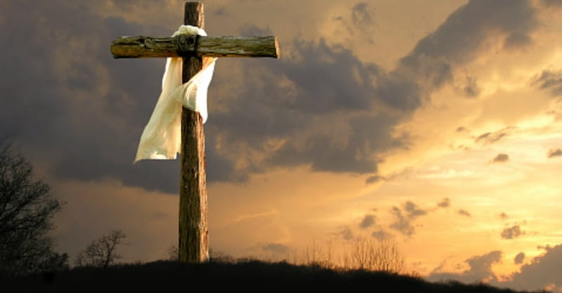

**Christians read the ‘big story’ of the Bible as pointing out the need for God to save people. This salvation includes the ongoing restoration of humans’ relationship with God.**

**The Gospels give accounts of Jesus’ death and resurrection. • The New Testament says that Jesus’ death was somehow ‘for us**

**Christians interpret this in a variety of ways: for example, as a sacrifice for sin; as a victory over sin, death and the devil; paying the punishment as a substitute for everyone’s sins; rescuing the lost and leading them to God; leading from darkness to light.**

**Christians remember Jesus’ sacrifice through the service of Holy Communion (also called the Lord’s Supper, the Eucharist or the Mass)**

**Outcomes**

Outline the timeline of the ‘big story’ of the Bible, explaining how Incarnation and Salvation fit within it.

Explain what Christians mean when they say that Jesus’ death was a sacrifice, using theological terms.

Suggest meanings for narratives of Jesus’ death/ resurrection, comparing their ideas with ways in which Christians interpret these texts.

Make clear connections between the Christian belief in Jesus’ death as a sacrifice and how Christians celebrate Holy Communion/Lord’s Supper.

Show how Christians put their beliefs into practice.

Weigh up the value and impact of ideas of sacrifice in their own lives and the world today

**Upper Key Stage 2 – Unit 2b.6 – Salvation**

**What did Jesus do to save human beings?**

**Key Vocabulary**

**Incarnation**

God in human form

God in the flesh

**Salvation**

Jesus rescuing people

**Crucifixion**

being killed by being nailed to a cross

**Resurrection**

coming back alive

**Easter**

Festival when Christians celebrate Jesus resurrection

**Holy Week**

The week leading up to Easter including Palm Sunday and Good Friday

**Betrayal**

Not being loyal/ betraying someone’s trust

**Sacrifice**

to give up something that is [valuable](https://dictionary.cambridge.org/dictionary/english/valuable) to you in [order](https://dictionary.cambridge.org/dictionary/english/order) to [help](https://dictionary.cambridge.org/dictionary/english/help) another [person](https://dictionary.cambridge.org/dictionary/english/person)

**Holy Communion**

[Holy](https://www.collinsdictionary.com/dictionary/english/holy) [Communion](https://www.collinsdictionary.com/dictionary/english/communion) is the most [important](https://www.collinsdictionary.com/dictionary/english/important) [religious](https://www.collinsdictionary.com/dictionary/english/religious) [service](https://www.collinsdictionary.com/dictionary/english/service) in the [Christian](https://www.collinsdictionary.com/dictionary/english/christian) [church](https://www.collinsdictionary.com/dictionary/english/church), in which people [share](https://www.collinsdictionary.com/dictionary/english/share) [bread](https://www.collinsdictionary.com/dictionary/english/bread) and [wine](https://www.collinsdictionary.com/dictionary/english/wine) as a [symbol](https://www.collinsdictionary.com/dictionary/english/symbol) of the [Last](https://www.collinsdictionary.com/dictionary/english/last) [Supper](https://www.collinsdictionary.com/dictionary/english/supper) and the [death](https://www.collinsdictionary.com/dictionary/english/death) of [Christ](https://www.collinsdictionary.com/dictionary/english/christ)

**Stations of the Cross**

A series of pictures depicting Jesus Christ on the day of his crucifixtion

**Pontious Pilate**

the Roman procurator of Judea who ordered that Jesus be crucified

**Sanhedrin**

the supreme council of the Jewish people in the time of Christ and earlier.

**Sin**

transgress those boundaries God has set for us



**Christians read the ‘big story’ of the Bible as pointing out the need for God to save people. This salvation includes the ongoing restoration of humans’ relationship with God**

**The Gospels give accounts of Jesus’ death and resurrection**

**Belief in Jesus’ resurrection confirms to Christians that Jesus is the incarnate Son of God, but also that death is not the end.**

**This belief gives Christians hope for life with God, starting now and continuing in a new life (heaven).**

**Key Vocabulary**

**Incarnation**

God in human form

God in the flesh

**Salvation**

Jesus rescuing people

**Crucifixion**

being killed by being nailed to a cross

**Resurrection**

coming back alive

**Easter**

Festival when Christians celebrate Jesus resurrection

**Holy Week**

The week leading up to Easter including Palm Sunday and Good Friday

**Betrayal**

Not being loyal/ betraying someone’s trust

**Sacrifice**

to give up something that is [valuable](https://dictionary.cambridge.org/dictionary/english/valuable) to you in [order](https://dictionary.cambridge.org/dictionary/english/order) to [help](https://dictionary.cambridge.org/dictionary/english/help) another [person](https://dictionary.cambridge.org/dictionary/english/person)

**Holy Communion**

[Holy](https://www.collinsdictionary.com/dictionary/english/holy) [Communion](https://www.collinsdictionary.com/dictionary/english/communion) is the most [important](https://www.collinsdictionary.com/dictionary/english/important) [religious](https://www.collinsdictionary.com/dictionary/english/religious) [service](https://www.collinsdictionary.com/dictionary/english/service) in the [Christian](https://www.collinsdictionary.com/dictionary/english/christian) [church](https://www.collinsdictionary.com/dictionary/english/church), in which people [share](https://www.collinsdictionary.com/dictionary/english/share) [bread](https://www.collinsdictionary.com/dictionary/english/bread) and [wine](https://www.collinsdictionary.com/dictionary/english/wine) as a [symbol](https://www.collinsdictionary.com/dictionary/english/symbol) of the [Last](https://www.collinsdictionary.com/dictionary/english/last) [Supper](https://www.collinsdictionary.com/dictionary/english/supper) and the [death](https://www.collinsdictionary.com/dictionary/english/death) of [Christ](https://www.collinsdictionary.com/dictionary/english/christ)

**Stations of the Cross**

A series of pictures depicting Jesus Christ on the day of his crucifixtion

**Pontious Pilate**

the Roman procurator of Judea who ordered that Jesus be crucified

**Sanhedrin**

the supreme council of the Jewish people in the time of Christ and earlier.

**Sin**

transgress those boundaries God has set for us

**Upper Key Stage 2 – Unit 2b.7 – Salvation**

**What difference does the resurrection make to Christians?**

**Outcomes**

Outline the timeline of the ‘big story’ of the Bible, explaining the place within it of the ideas of Incarnation and Salvation.

Suggest meanings for resurrection accounts, and compare their ideas with ways in which Christians interpret these texts, showing awareness of the centrality of the Christian belief in Resurrection.

Explain connections between Luke 24 and the Christian concepts of Sacrifice, Resurrection, Salvation, Incarnation and Hope, using theological terms.

Make clear connections between Christian belief in the Resurrection and how Christians worship on Good Friday and Easter Sunday.

Show how Christians put their beliefs into practice in different ways.

Explain why some people find belief in the Resurrection makes sense and inspires them.

Offer and justify their own responses as to what difference belief in Resurrection might make to how people respond to challenges and problems in the world today.

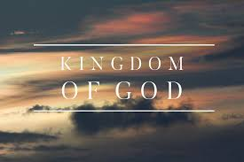

**Many Christians try to extend the Kingdom of God by challenging unjust social structures in their locality and in the world.**

**The Kingdom is compared to a feast where all are invited to join in. Not everyone chooses to do so.**

**Jesus told many parables about the Kingdom of God. These suggest that God’s rule has begun, through the life, teaching and example of Jesus, and subsequently through the lives of Christians who live in obedience to God.**

**Key Vocabulary**

**Pentecost**

The day when the Holy Spirit was given to Christians.

**Holy Spirit**

One of the three persons of the Trinity of God.

**Guide**

Someone who shows the way.

**Comforter**

Looks after in times of need.

**Resurrection**

coming back alive

**Kingdom of God**

**Fellowship**

It is the sharing of knowledge and the trials and triumphs of life among those who are called and chosen of God

**Fruits of the spirit**

The Fruit of the Holy Spirit is a biblical term that sums up nine attributes of a person or community living in accord with the Holy Spirit

**Disciples**

A dedicated follower of Jesus

**Ascension**

The Ascension of Jesus is the physical departure of Christ from Earth into the presence of God in Heaven

**Upper Key Stage 2 – Unit 2b.8 – Kingdom of God What kind of King was Jesus?**

**Outcomes**

Explain connections between biblical texts and the concept of the Kingdom of God.

Consider different possible meanings for the biblical texts studied, showing awareness of different interpretations.

Make clear connections between belief in the Kingdom of God and how Christians put their beliefs into practice in different ways, including in worship and in service to the community.

Relate Christian teachings or beliefs about God’s Kingdom to the issues, problems and opportunities of their own lives and the life of their own community in the world today, offering insights about whether or not the world could or should learn from Christian ideas.