Year 4

Electricity

**Knowledge Organiser**

VOCABULARY

**Electricity-** form of energy formed by charged particles.

**Circuit-** a complete flow of electricity and the way it affects objects.

**Bulb**- provides light when powered.

**Mains**- domestic or wall powered.

**Plug**- device for making an electrical connection

**Buzzer**- An electrical device that makes a buzzing sound.

**Wire**- A long piece of metal that carries an electrical current often covered in plastic for safety.

**Motor**- A device that changes electrical energy into movement.

**Cell**- a device used to generate electricity.

**Battery**- More than one cell/

**Conductor-** Any material that electricity can pass through or along.

**Insulator-** Any material that electricity cannot pass through or along.

**Symbol-** Representation of the components.

**Electrons-** move around a circuit.

**Current-** stream of charged particles moving though an electrical conductor.

**Voltage-** An electrical force that makes electricity move through a wire, measured in volts (V)

**r**

Electricity can produce…

The battery produces electricity. It has stored chemical energy.

The chemical energy converts to electrical energy which produces electrons. They travel around the circuit to all the components.

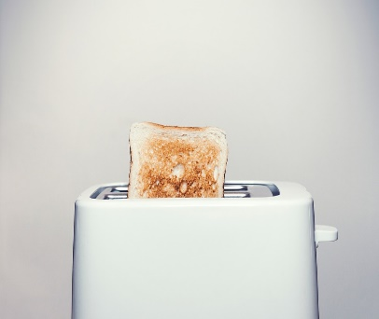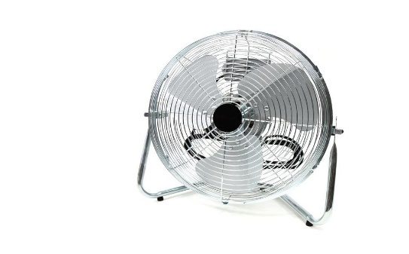nnh

Heat

Movement

Sound

Light

Circuit Components

Simple Circuit

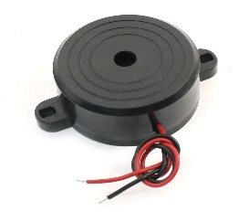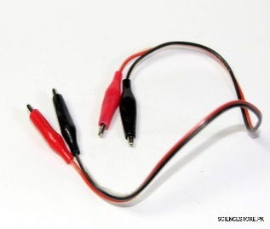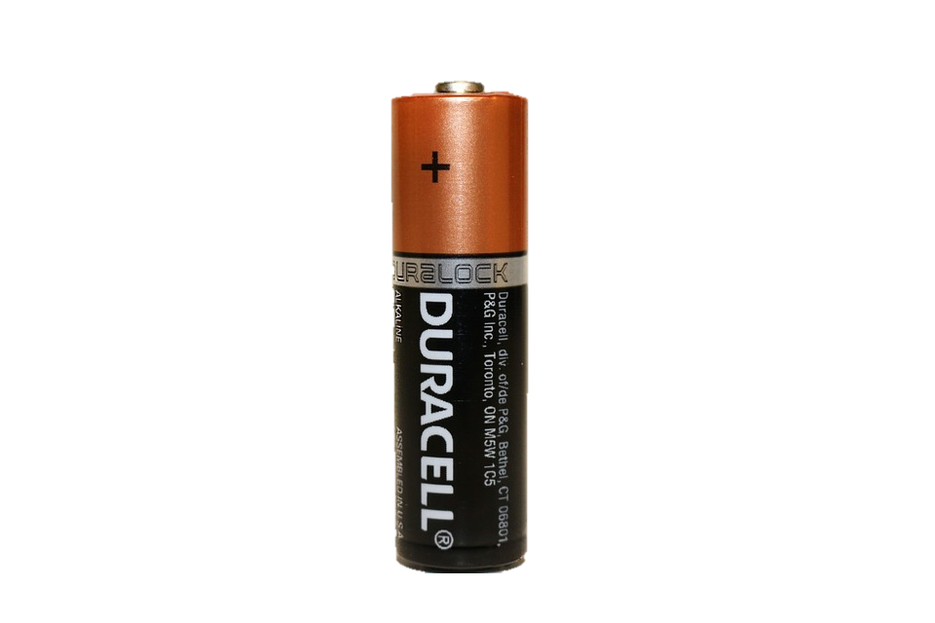

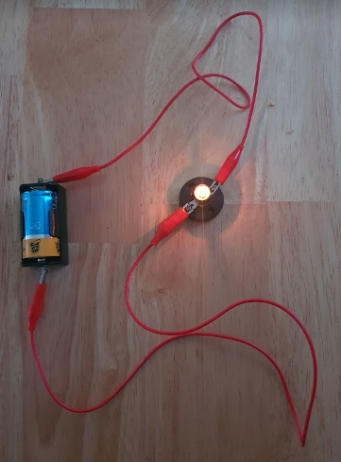

This is a simple circuit. It is a complete circuit where electrons can flow around the circuit.

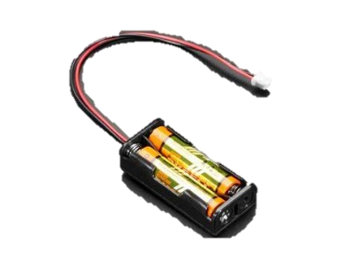

Buzzer

Wires

Bulb/Lamp

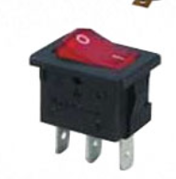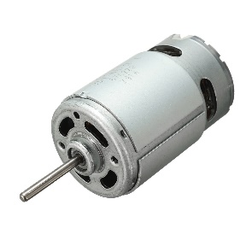

Cell

Battery



Motor

Switch

Year 4

Electricity

Scientific Diagrams and Symbols

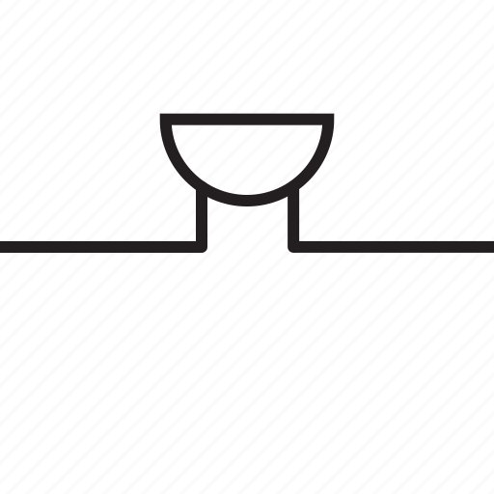

Bulb

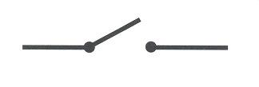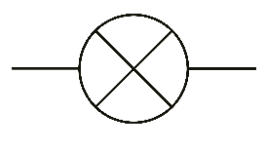

Switch

Cell

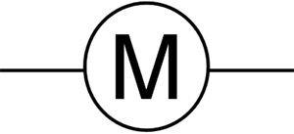

Buzzer

Bulb

Wires



Cell

Motor

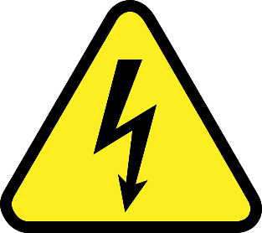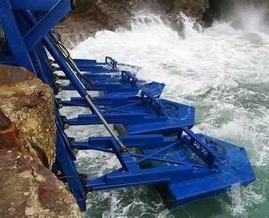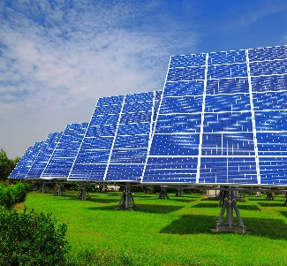

2000- Wave Power

1956- Nuclear Power

1941- Solar Power

He developed many devices including the early version of the electric light bulb.

Thomas Edison

First person to discover that moving a magnet near a coil of copper wire introduced an electric current in a wire.

Michael Faraday

He discovered the first practical method of making electricity.

Alessandro Volta

Science Capital

Switch