Spelling test: Year 6
Given:6.9.22
Test: 27.9.22
Spellings
across
after
again
air
along
am

Spelling test: Year 5
Given:6.9.22
Test: 27.9.22
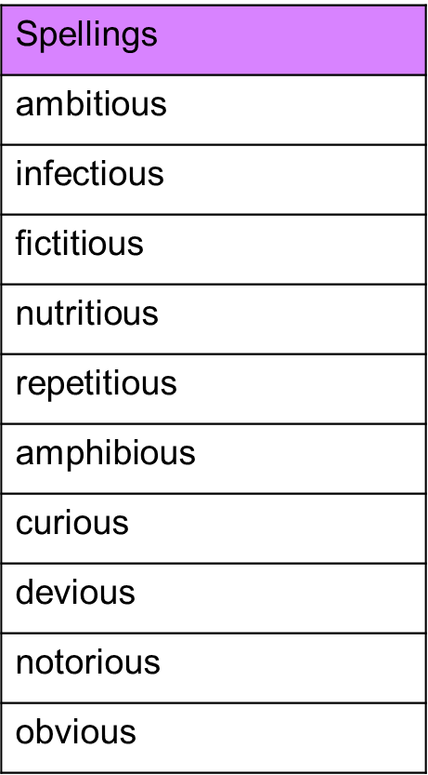

Spelling test: Year 6
Given:6.9.22
Test: 27.9.22
