Spelling Test: Year 6
Given: 6.12.22
Test: 13.12.22
Rule: High Frequency Words
Spellings
first
fish
floppy
food
found
fox

Spelling test: Year 5
Given: 6.12.22
Test: 13.12.22
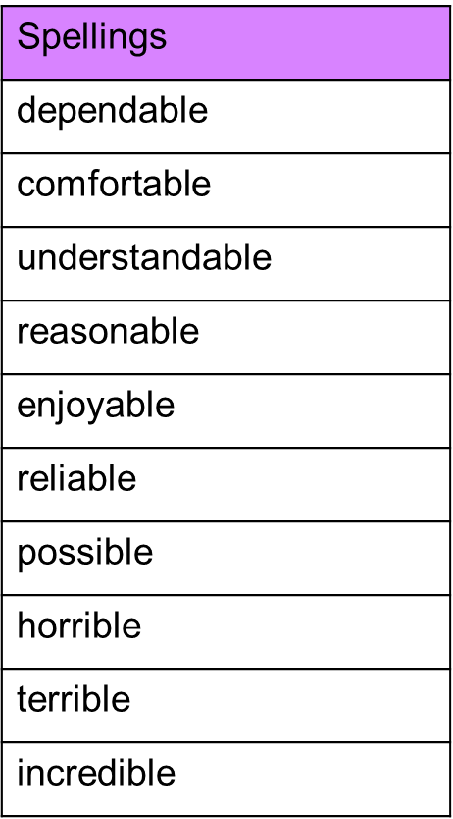
Rule: words ending in –able and -ible

Spelling test: Year 6
Given: 6.12.22
Test: 13.12.22
Rule: Challenge words