Spelling Test: Year 6
Given: 3.1.23
Test: 10.1.23
Rule: High Frequency Words
Spellings
friends
fun
garden
gave
giant
girl

Spelling test: Year 5
Given: 3.1.23
Test: 10.1.23
Rule: words ending in –ably or –ibly
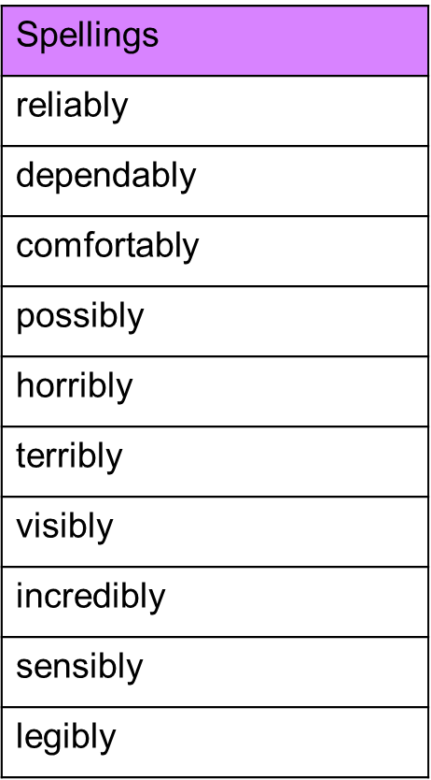

Spelling test: Year 6
Given: 3.1.23
Test: 10.1.23
Rule: Words with the short vowel sound /i/ spelled 'y'

