Spelling Test: Year 6
Given: 10.1.23
Test: 17.1.23
Rule: High Frequency Words
Spellings
going
gone
good
gran
grandad
great

Spelling test: Year 5
Given: 10.1.23
Test: 17.1.23
Rule: Challenge words
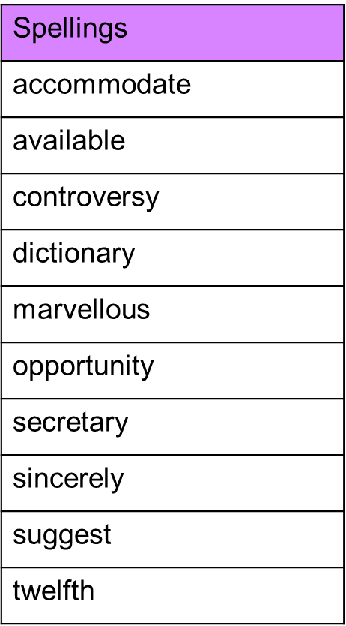

Spelling test: Year 6
Given: 10.1.23
Test: 17.1.23
Rule: Words with the long vowel sound /igh/ spelled 'y'
