Spelling Test: Year 6
Given: 17.1.23
Test: 24.1.23
Rule: High Frequency Words
Spellings
green
grow
he’s
hard
has
has

Spelling test: Year 5
Given: 17.1.23
Test: 24.1.23
Rule: Words ending in '-able' where the 'e' from the base word remains
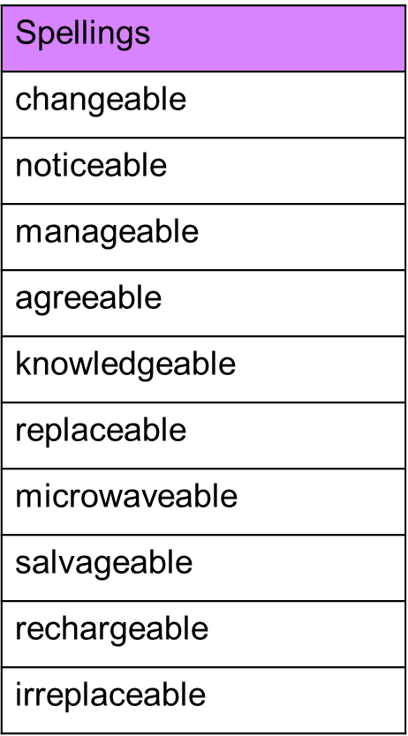

Spelling test: Year 6
Given: 17.1.23
Test: 24.1.23
Rule: Words with the prefix 'over-‘
