Spelling Test: Year 6
Given: 31.1.23
Test: 7.2.23
Rule: High Frequency Words
Spellings
I’ve
inside
key
its
jumped
keep

Spelling test: Year 5
Given: 31.1.23
Test: 7.2.23
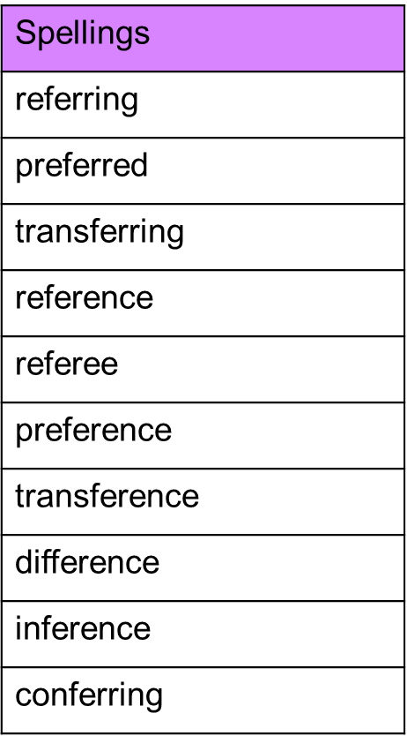
Rule: Words with suffixes where the base word ends in ‘-fer’

Spelling test: Year 6
Given: 31.1.23
Test: 7.2.23
Rule: Words that can be nouns and verbs
Spellings
produce
impact
transport
silence
permit
object
contest
subject
increase
freeze

