Spelling Test: Year 6
Given: 7.2.23
Test: 14.2.23
Rule: High Frequency Words
Spellings
king
know
last
laughed
let
let’s

Spelling test: Year 5
Given: 7.2.23
Test: 14.2.23
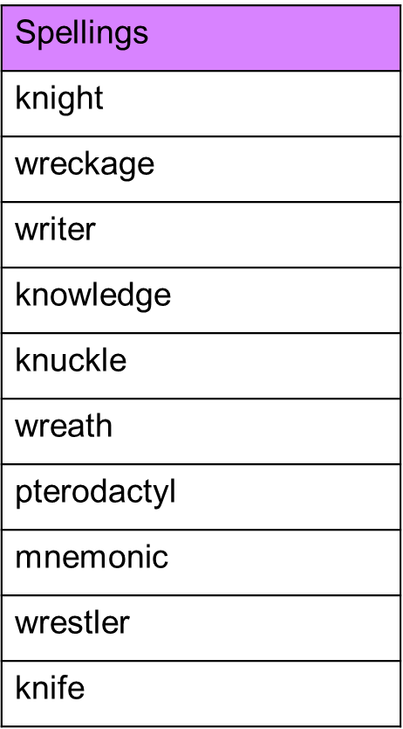
Rule: Words with silent first letters

Spelling test: Year 6
Given: 7.2.23
Test: 14.2.23
Rule: Words with an /oa/ sound spelled 'ou' or 'ow'
