Spelling Test: Year 6
Given: 14.2.23
Test: 28.2.23
Rule: High Frequency Words
Spellings
liked
long
looking
live
lived
looks

Spelling test: Year 5
Given: 14.2.23
Test: 28.2.23
Rule: Words with silent letters
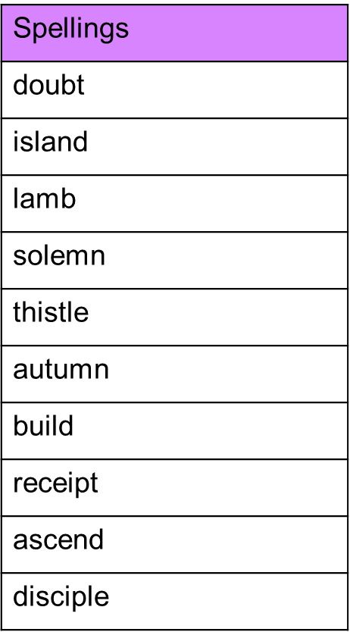

Spelling test: Year 6
Given: 14.2.23
Test: 28.2.23
Rule: Words with a soft ‘c’ spelled ‘ce’
