Spelling Test: Year 6
Given: 7.3.23
Test: 14.3.23
Rule: High Frequency Words
Spellings
more
morning
most
mother
mouse
much

Spelling test: Year 5
Given: 7.3.23
Test: 14.3.23
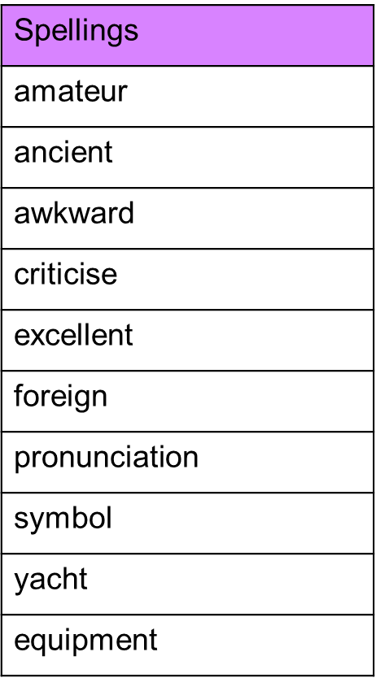
Rule: Challenge words

Spelling test: Year 6
Given: 7.3.23
Test: 14.3.23
Rule: Words with the prefixes 'dis-', 'un-', 'over-' and 'im-'