Spelling Test: Year 5
Given: 27.9.22
Test: 4.10.22
Rule: High Frequency Words
Spellings
animals
another
any
around
away
baby

Spelling test: Year 5
Given: 27.9.22
Test: 4.10.22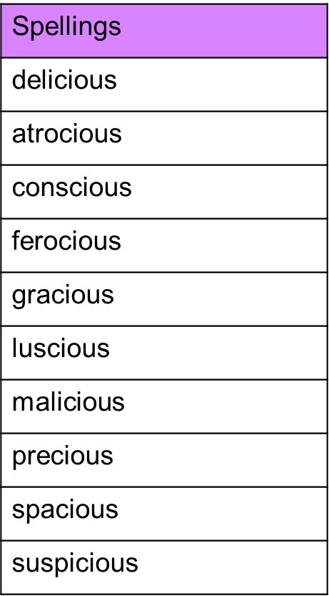

Spelling test: Year 6
Given: 27.9.22
Test: 4.10.22