Spelling Test: Year 6
Given: 4.10.21
Test: 11.10.21
Rule: High Frequency Words
Spellings
bad
bear
because
bed
been
before

Spelling test: Year 5
Given: 4.10.21
Test: 11.10.21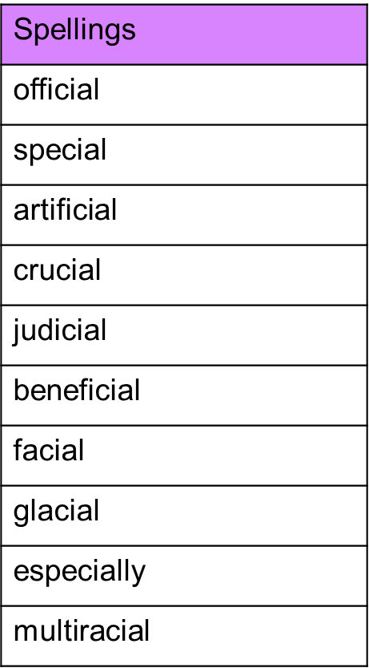

Spelling test: Year 6
Given: 4.10.21
Test: 11.10.21