Spelling Test: Year 6
Given: 1.11.22
Test: 8.11.22
Rule: High Frequency Words
Spellings
coming
couldn’t
cried
dark
did
didn’t

Spelling test: Year 5
Given: 1.11.22
Test: 8.11.22
Rule: Challenge words
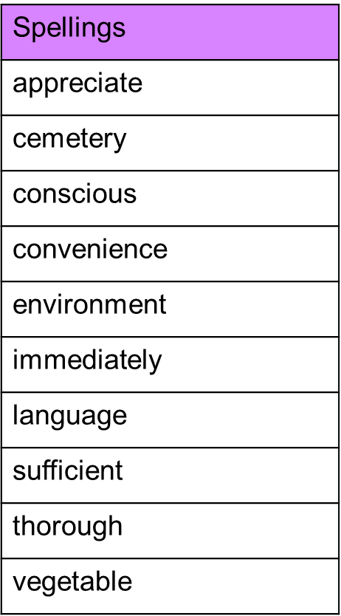

Spelling Test: Year 6
Given: 1.11.22
Test: 8.11.22
Rule: Challenge words
