Spelling Test: Year 6
Given: 15.11.22
Test: 22.11.22
Rule: High Frequency Words
Spellings
different
dragon
dog
duck
door
each

Spelling test: Year 5
Given: 15.11.22
Test: 22.11.22
Rule: words ending in -ant
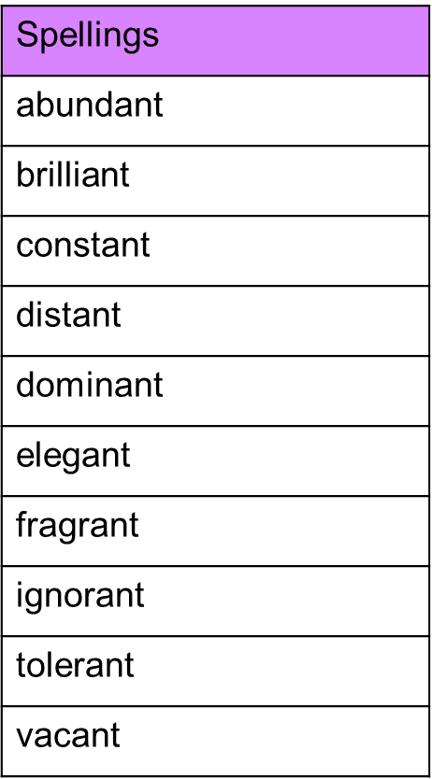

Spelling Test: Year 6
Given: 15.11.22
Test: 22.11.22
Rule: Challenge words
