Spelling Test: Year 6
Given: 22.11.22
Test: 29.11.22
Rule: High Frequency Words
Spellings
eat
eggs
and
even
ever
every

Spelling test: Year 5
Given: 22.11.22
Test: 29.11.22
Rule: words ending in -ance and -ancy
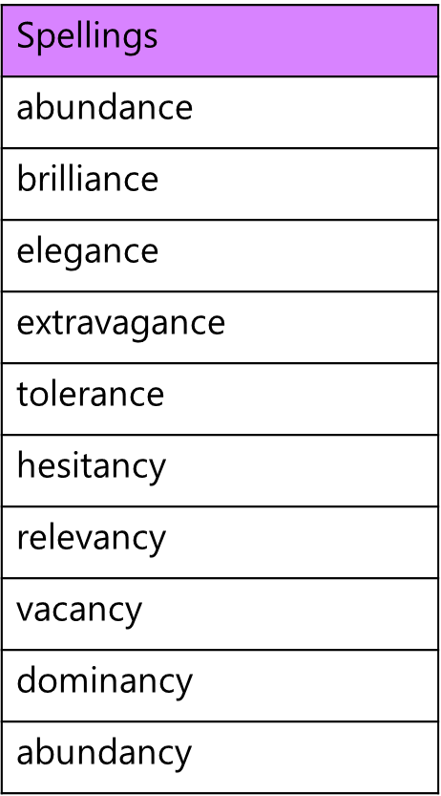

Spelling test: Year 6
Given: 22.11.22
Test: 29.11.22
Rule: Challenge words 