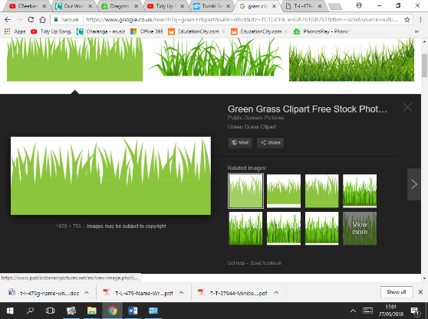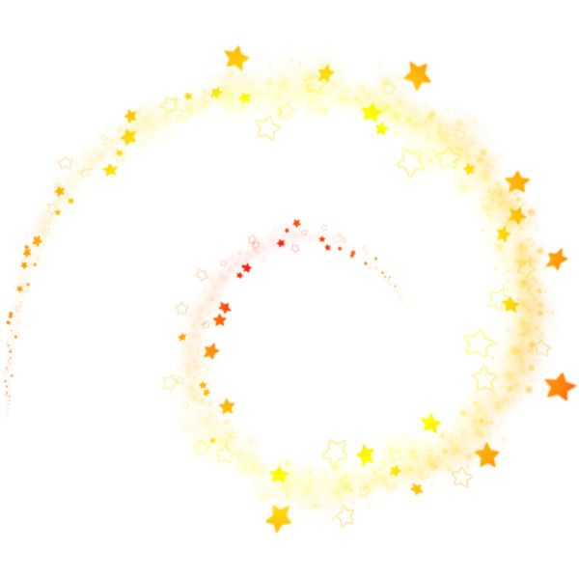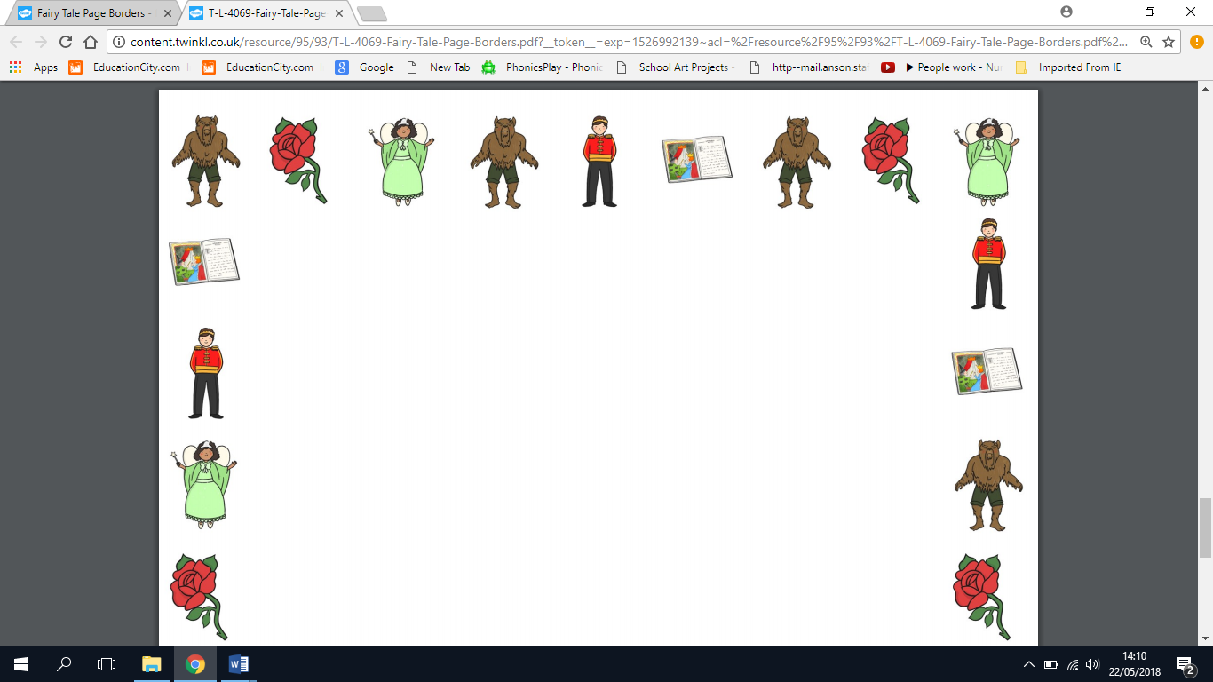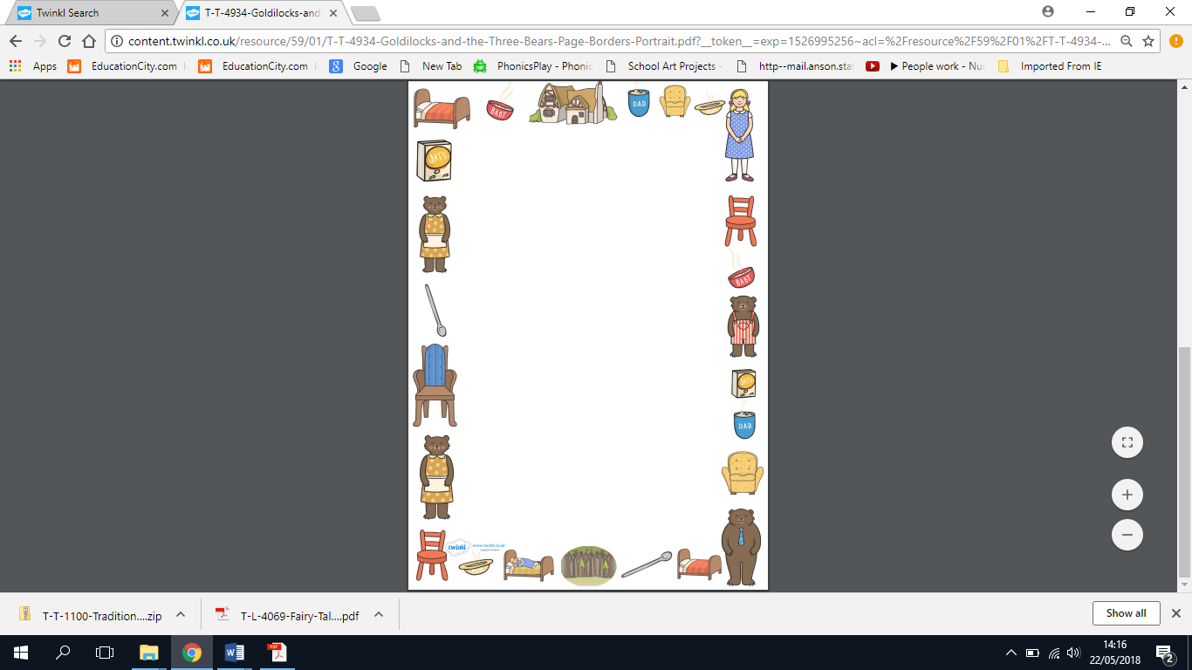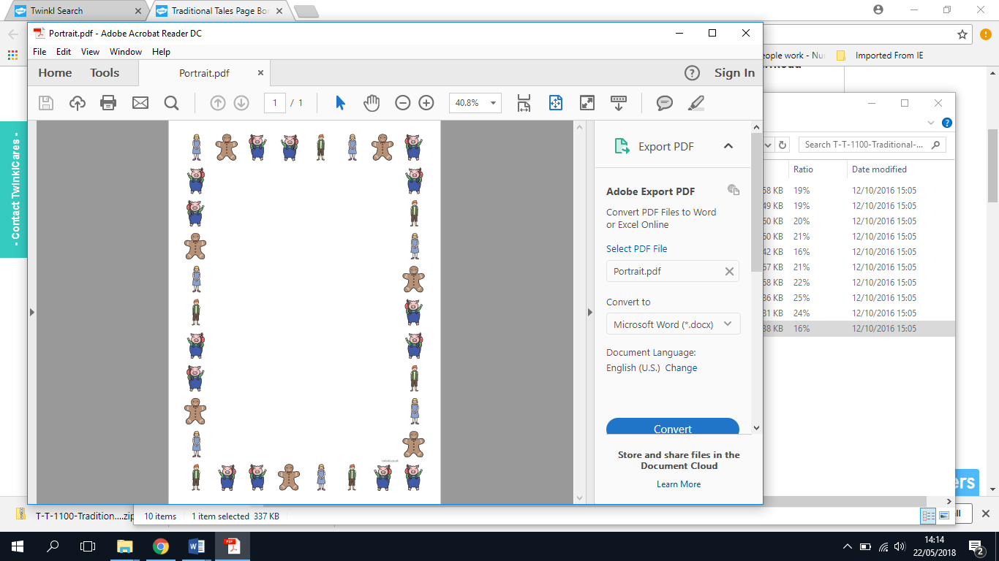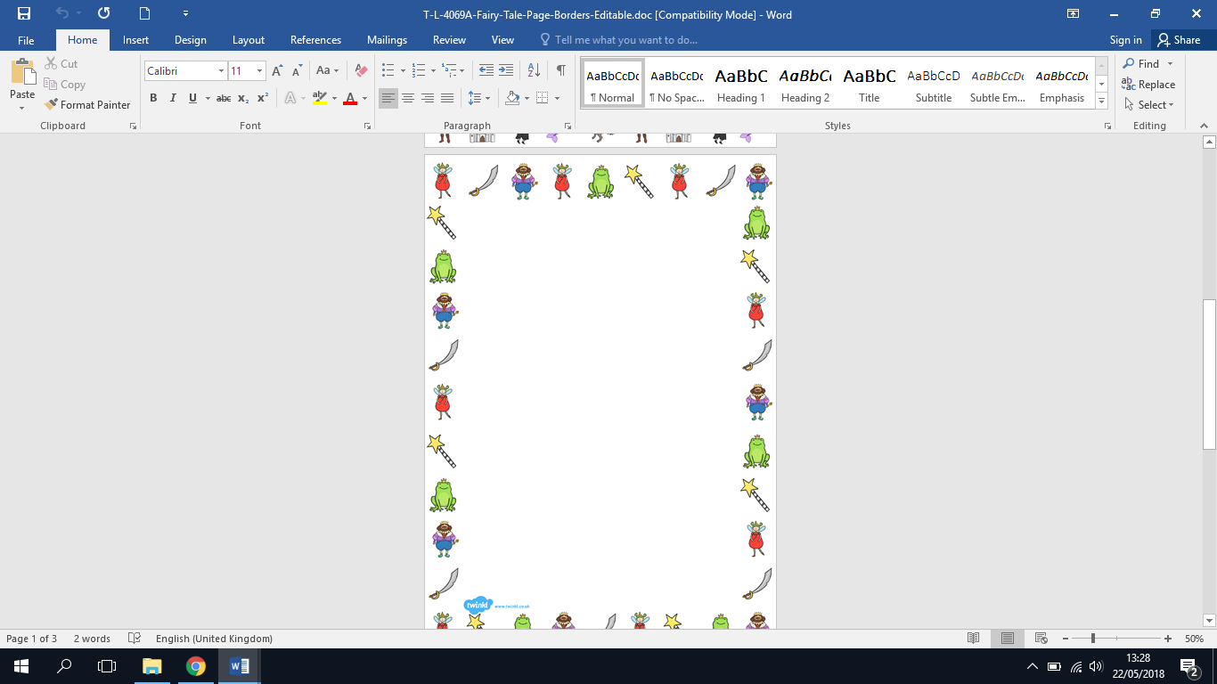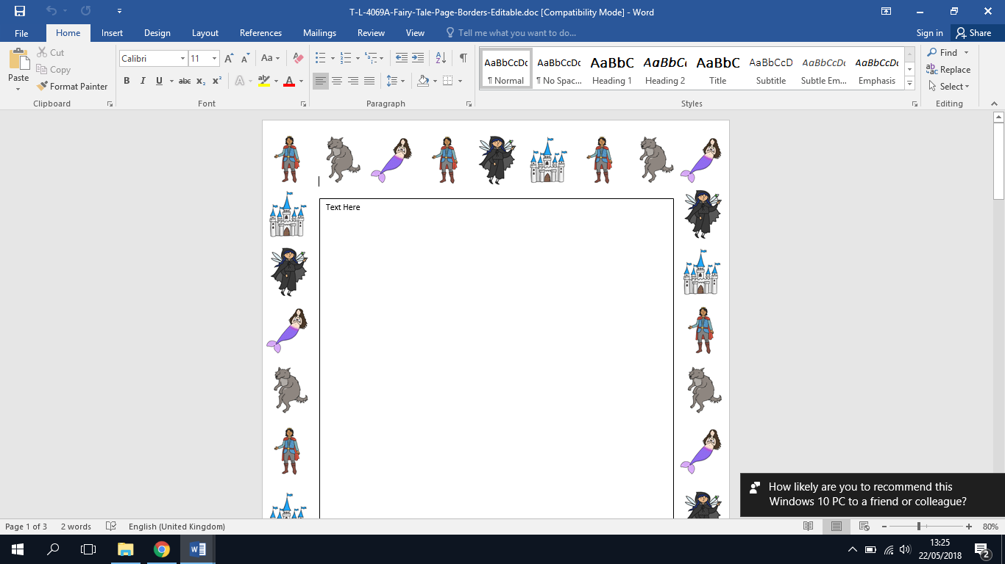

Our topic for the next term will be Fairy tales and Traditional Stories.

Please choose from the activities below to complete over half term. Please send the homework that you complete to [anson.class1@tssmat.staffs.sch.uk](mailto:anson.class1@tssmat.staffs.sch.uk) by Tuesday 2nd June. (Please also use this time, if you would like, to catch up on any missed weekly home learning tasks that have not been completed yet).

Can you tell us about a time in your life when you have felt like a prince or princess? Maybe you have a photo you could share.

Imagine you are in your own fairy tale, who would you be? Where would you live? Who else would be with you? Draw a picture or write sentences to show us!

Explore in the woods/forest, what kind of things did you find on your adventures? Watch out for the bears!

Practise your tricky words and sounds we have learnt over the past few weeks – dress up as a Fairy tale character and imagine you are the teacher teaching your favourite characters.

Make your own castle or palace, you could create a picture or use cardboard to build one!

Can you write a list of things you would put in a magic spell? What will your magic spell do?

Fairy tales

And

Traditional Stories

The three little pigs need your help. Can you make a 3D house out of a material that would be good to keep the wolf out?

Choose your favourite Fairy tale or Traditional stories, read and enjoy them with your family. Can you tell someone about the stories, talk about the characters, the setting and what happens.