

YOUR SCHOOL MENU 2025

and in the event of unforeseen circumstances.

WEEK 1

CHEEKY MONDAY
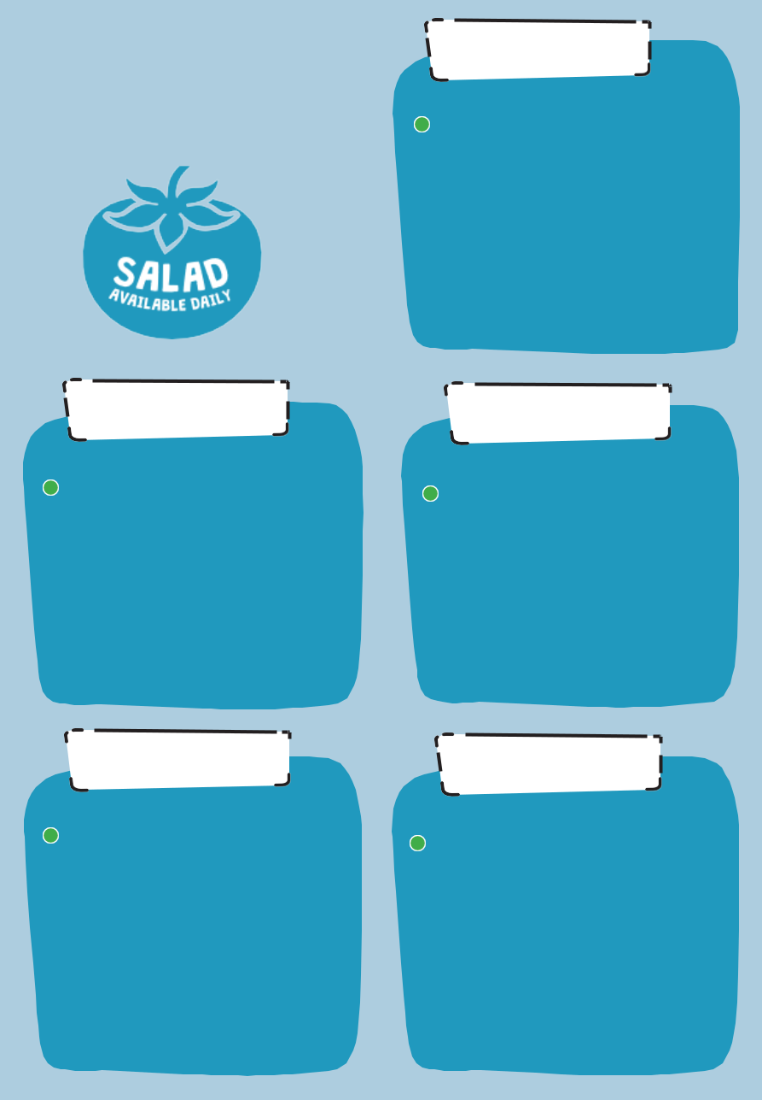

CHOOSE FROM

- Vegan Sausage Roll Pork Hot Dogs

ON THE SIDE

Vegetables of the day or salad

and chips

TO FINISH

Chocolate Brownie

WEEK 2

Our primary

school menus comply with the

Government’s food and nutritional
standards, meeting an average of 530
calories
for each meal

CHEEKY MONDAY
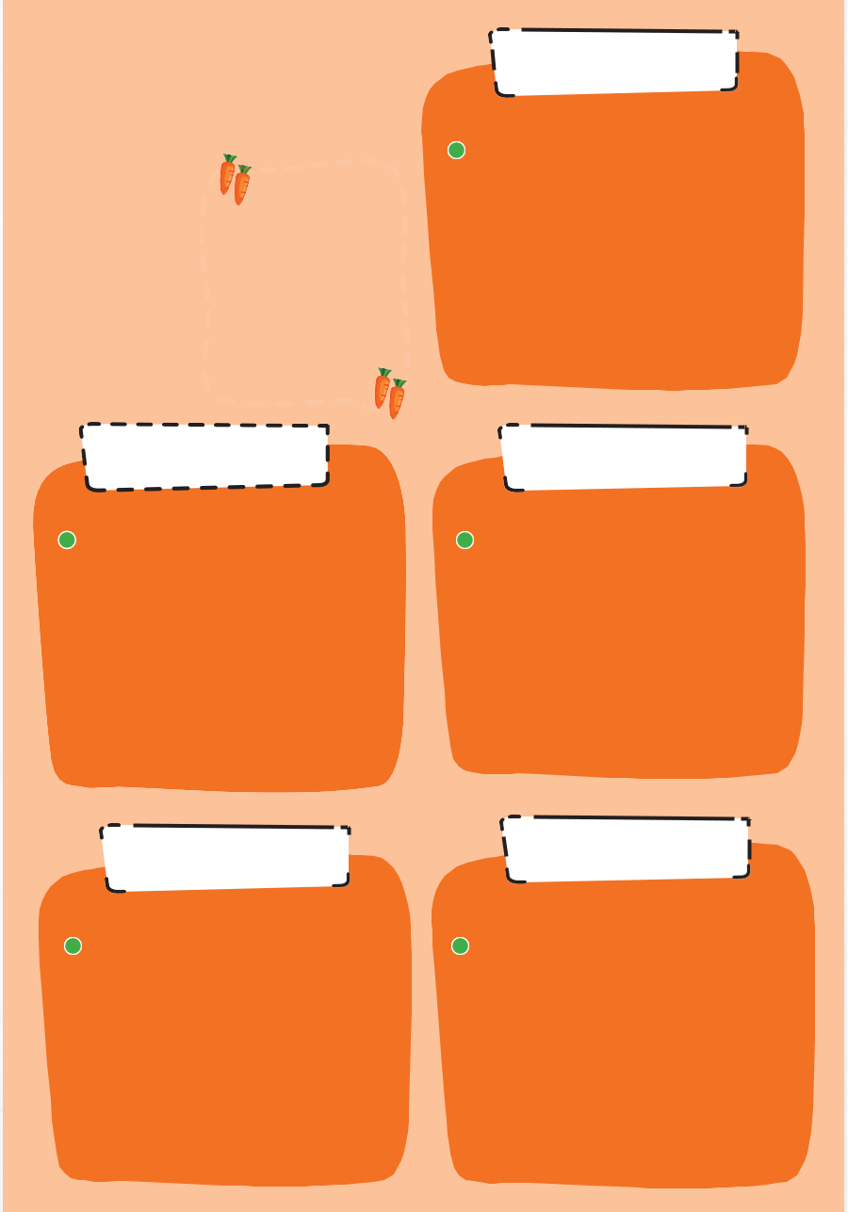

CHOOSE FROM

- Cheese and Onion Pasty Chicken Nuggets

ON THE SIDE

Vegetables of the day or Salad and Chips

TO FINISH

Croissants

WEEK 3

FRESH

FRUIT SALAD

SERVED

EVERY DAY

CHEEKY MONDAY


CHOOSE FROM

- Vegan Sausage Roll

Beef Burger

ON THE SIDE

Vegetables of the day or Salad and Chips

TO FINISH

Raisin Sponge

items are subject to change, based upon availability

PASTA TUESDAY

CHOOSE FROM

- Macaroni Cheese with Garlic Bread

Pasta and Meatballs

ON THE SIDE

Vegetables of the day or Salad

TO FINISH

Yogurt or Jelly

PIZZA WEDNESDAY

CHOOSE FROM

- Homemade Margherita Pizza Homemade Pepperoni Pizza

ON THE SIDE

Vegetables of the day or salad and crinkle cut wedges

TO FINISH

Homemade Cookies

PASTA TUESDAY

CHOOSE FROM

- Tomato and Basil Pasta Bake

Ham Carbonara with Pasta and Garlic Bread

ON THE SIDE

Vegetables of the day or Salad

TO FINISH

Banana Sponge or Yoghurt

PIZZA WEDNESDAY

CHOOSE FROM

- Homemade Margherita Pizza

Homemade Cheese and Ham Pizza

ON THE SIDE

Vegetables of the day or salad and crinkle cut wedges

TO FINISH

Jelly or Yoghurt

PASTA TUESDAY

CHOOSE FROM

- Mediterranean Veg Pasta Bake with Garlic Bread

Spaghetti Bolognaise

ON THE SIDE

Vegetables of the day or Salad

TO FINISH

Homemade Cookies
PIZZA WEDNESDAY

CHOOSE FROM

- Handmade Margherita Pizza

Homemade Ham and Sweetcorn Pizza

ON THE SIDE

Vegetables of the day and crinkle cut wedges

TO FINISH

Chocolate Sponge

FISH FRIDAY

V Vegetarian Vg Vegan All menu

CHICKEN THURSDAY

CHOOSE FROM

- Vegan Chicken Nuggets Chicken Korma and Rice
ON THE SIDE

Vegetables of the day or Salad and Diced Potatoes

TO FINISH

Chocolate Sponge

FISHRIDAYF

CHOOSE FROM

- Quorn Sausages Breaded Cod
ON THE SIDE

Peas or beans and Chips

TO FINISH

Ice Cream or Ice Lolly

CHICKEN THURSDAY

CHOOSE FROM

- Vegan Chicken Nuggets Chicken Burger

ON THE SIDE

Vegetables of the day or Salad and Diced Potatoes

TO FINISH

Toffee Sponge

FISH FRIDAY

CHOOSE FROM

- Vegan Sausage Roll Breaded Cod

ON THE SIDE

Peas or beans and Chips

TO FINISH

Ice Cream or Ice Lolly

CHICKEN THURSDAY

CHOOSE FROM

- Vegan Chicken Nuggets Italian Chicken

ON THE SIDE

Vegetables of the day or Salad and Diced Potatoes

TO FINISH

Jelly and Yoghurt

CHOOSE FROM

- Quorn Hot Dogs

Breaded Cod

ON THE SIDE

Peas or beans and Chips

TO FINISH

Ice Cream or Ice Lolly

Light bite options available. Daily sandwiches, jacket potatoes with fresh daily fillings

