

 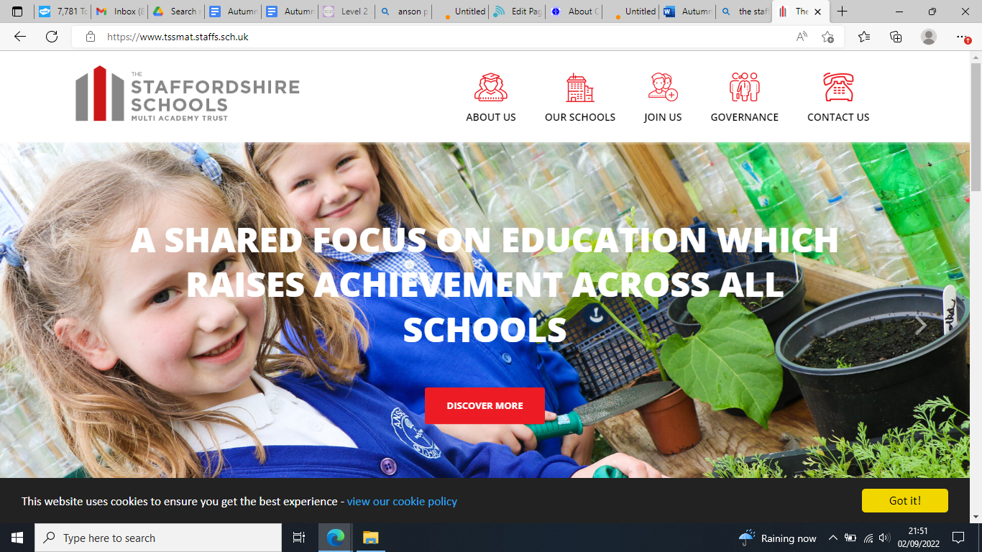

Dear Parents/Carers,

Welcome to Anson Primary School! We hope you have had a lovely summer and are looking forward to your child starting their learning journey at Anson. Your child is starting school in Class 1 - which is our Reception Early Year Foundation Stage class, the Early Years team is made up of teachers - Mrs Heath, Mrs Philp and teaching assistants Mrs Castell, Mrs Bater and Mrs Elwell.

We spend much of our first term getting to know your child and our first two topics are ‘Marvellous Me’ and ‘People who help us’. You can find details of our intended learning over the page. The children will be working towards individual targets and reaching their Early Learning Goals throughout the year. A baseline assessment will be done in the first few weeks of the term, it is nothing to worry about, it is to help us to see where your child is in their learning. This is done in a fun way and your child will not know about any assessment at all!

Class Information:

Before and After school routines: The school gates are opened at 8.43am, Class 1 children should line up and enter at the blue Early Years gate in the playground. They will be greeted by a member of the early years team and led into the classroom. Registration closes at 9am. At the end of the day please collect your child from this same gate, where children will be dismissed one at a time to their collecting grown up at 3.15pm.

Uniform: Please ensure that ALL uniform including PE kits are clearly labelled with your child’s name. Your child will also need to have a bag with a spare change of clothes that can stay in school - just in case!

PE: Class 1 has P.E every Thursday, please ensure your child brings their labelled PE kit to school in their PE bag.

Snack & Milk: All children are provided with fruit and milk every day at snack time free of charge.

Water bottles: Each child should bring a water bottle into school that is clearly named, bottles will be returned home at the end of each day for washing and refilling. Children can have a drink from these at any time throughout the school day and are also sent outside at breaks and lunches.

Wellies: Please ensure that your child brings in a pair of wellies with them on their first day, which are clearly labelled. These will be kept in school throughout the year, we try to go outside in all weathers in our rain suits!

Readers: After the first few weeks of this term your child will begin to bring home a reading book. Initially these will be books with just pictures, this is a lovely way to begin sharing story time with your child and begin their excitement for reading. Following assessments and where we are at in our phonics scheme your child will bring home reading books at their stage of reading. Reading books should be read each night, please help your child to read and enjoy their book and write a comment in their diary to show us that your child has read or any comments you would like to pass on. **Reading books will be changed every Monday** if they are bought in with the diary signed. Your child also has a login to 'Bug Club' where they have a variety of reading books set for them that they can access at home. Lots of children enjoy reading through Bug Club and this could be used if your child has finished their book

Diaries: Diaries will be checked every day for messages. They form an important line of communication between home and school, so please let us know any information on the right hand side of the page. It is helpful to write in the diary who will be picking your child up that day so we know who to look for and if it is someone new we can ask for your child’s password.

Documents and forms:If you haven’t already done so please remember to return your completed forms to the office as soon as possible, these can be found in your child’s starter pack.

Please do not hesitate to contact us at school if you have any questions or concerns

We look forward to making your child's first term at school a very exciting one!

Kind regards,

Mrs Heath, Mrs Philp and Mrs Castell, Mrs Bater, Mrs Elwell

Class 1 Teachers and Teaching Assistants

