Online Safety Newsletter

May 2022

World Password Day: 5th May 2022

We need to create passwords for everything these days and it is important that our children not only understand that they should not share passwords with others but also that they know how to create a ‘strong’ password to keep their information safe. As part of World Password Day, why not take the opportunity to talk to your child about this? You can learn more here:
https://www.connectsafely.org/passwords/
Social Media update
There are several different social media platforms that your child might be on or wanting to join such as Instagram and Snapchat. Social Media platforms are used to share pictures and communicate with others. It is important to review each individual platform to see what age your child should be to access them and to set appropriate privacy settings. It is also important to talk to your child about information they should keep private.

Is your child ready for social media?
This article looks at the risks that you need to consider as well as advice on how to get started:
https://www.thinkuknow.co.uk/parents/articles/is-my-child-ready-for-social-media/

Further information
Visit the Social Media Advice hub from Internet Matters to learn more:
https://www.internetmatters.org/resources/social-media-advice-hub/
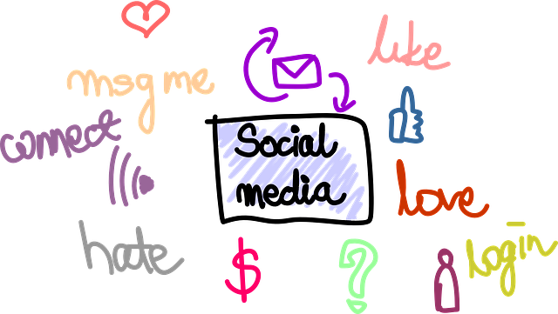

TikTok update

The NSPCC have created a news article discussing if TikTok is safe for children and provides an overview of how to keep your child safe on TikTok using their safety settings. Read the article here:
https://www.nspcc.org.uk/keeping-children-safe/online-safety/online-safety-blog/child-safe-settings-tiktok

TikTok have also created a Guardian’s Guide designed to provide an overview of TikTok and the tools and controls available:
https://www.tiktok.com/safety/en/guardians-guide/

New CyberSprinters activities (7 – 11 year olds)

The National Cyber Security Centre have released a new set of activities and interactive stories. As well as the original CyberSprinters game (https://www.ncsc.gov.uk/collection/cybersprinters), you can now access puzzles that you can solve with your child and read interactive stories together. These activities are available here: https://www.ncsc.gov.uk/collection/cybersprinters/home-activities.

These resources will encourage conversations about how we can keep our information secure online.

Users of this guide do so at their own discretion. No liability is entered into. Current as of the date released 1.05.22.

Games from Childline

Childline have created some online games that your children can play including arcade style games and relaxing games. You can find them here:

https://www.childline.org.uk/toolbox/games/

Pop Ups / Adverts
When your child is playing on certain games or is on social media, they may see adverts / pop up adverts. The content in these adverts may not always be appropriate to them, particularly if clicked on.

It is important to talk to your child about adverts and to think about what they are clicking on before they do and if they are unsure to either ignore them or to check with a trusted adult.
Search Engines

Parent Zone have published this article explaining what you need to know about safer searching and what you should consider. Read the article here:

https://parentzone.org.uk/article/search-engines-what-you-need-to-know

Further information
https://www.childnet.com/help-and-advice/security/pop-ups-adverts/
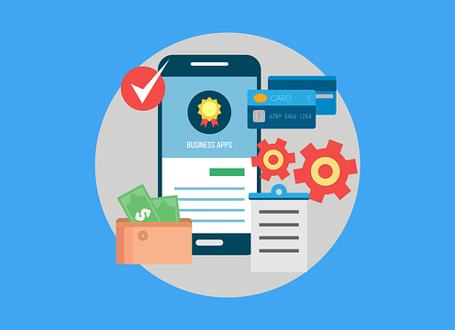

Apple Watches

Does your child wear an Apple watch to school? Do they know how to turn it to the appropriate setting for school? Apple offers two options:

- Do Not Disturb mode - turns off all alerts.
- Theatre Mode - enables silent mode and stops the watch display from waking when you raise your hand.

Family Setup

Family Setup can be used to set up an Apple Watch for a child that does not have their own iPhone. Once set up, there is a Schooltime option, which when activated displays a yellow circle on the watch to easily show that access to apps is restricted and Do Not Disturb is switched on. You can set the schedule for Schooltime on your iPhone. Find out more here:

https://support.apple.com/en-gb/HT211782

Online Sexual Harassment

Talking to our children about online sexual harassment can be difficult which is why the Children’s Commissioner have produced a guide to help you. The guide focuses on several topics that can often be difficult to talk about with our children such as body image and peer pressure.

Through the work of the Children’s Commissioner, they found that we should start these conversations early, introducing topics in an age-appropriate manner before a child is given a phone or a social media account (often around the age of 9 or 10). The guide is a ‘starting point’ and includes further links to other resources, young peoples’ views and top tips from 16–21 year-olds. The guide and further information can be found here:

https://www.childrenscommissioner.gov.uk/report/talking-to-your-child-about-online-sexual-harassment-a-guide-for-parents/

