ANSON CE PRIMARY SCHOOL

Main Road
Great Haywood
Stafford
ST18 0SU Tel no: 01889 881200
email office@anson.staffs.sch.uk

Dear Parents/Carers,

A key aim at Anson is to develop and instil a love of reading within our children throughout the school whilst teaching them the important skills of phonics, de-coding, fluency and comprehension. As a school, we prioritise phonics and early reading skills because when children learn to read at an early age, they have greater general knowledge, a wider range of vocabulary, can access all curriculum subjects, and they have improved attention spans and better concentration. Children who enjoy reading are more likely to become lifelong readers and at Anson we strive to help children to become readers for life. Below is an idea of the ways in which we aim to encourage a love of reading within pupils at Anson.

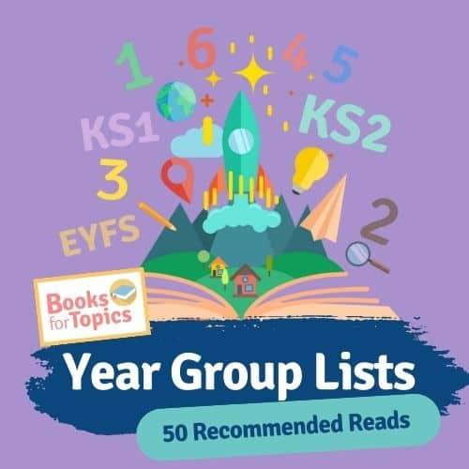
Recommended Reads:
Each year group has access to a selection of ‘Recommended Reads’. These texts have been carefully chosen to match your child’s reading age and aim to instil a love of reading. This year, children will be challenged to read as many of their recommended reads as possible and will write a book review after each one. Each book review counts as an entry into a competition where the child from each class who has read the most recommended reads will win a Kindle!

You can find the list of recommended reads for each year group on the ‘About Class’ pages for each class.
You can view the most recent list of recommended reads for your child’s age range here: https://www.booksfortopics.com/booklists/recommended-reads/

Anson’s Reading Spine:
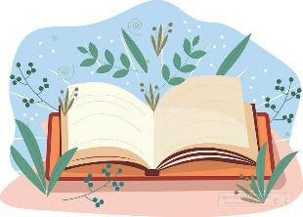
We have created a ‘Reading Spine’ filled with texts that your child will be exposed to during their time at Anson. These carefully chosen texts include fiction, non-fiction and poetry and make links to lots of the topics children will learn about across the curriculum. Children will be exposed to these stories during English lessons, Guided Reading lessons, during ERIC and reading for pleasure sessions and through themed days such as Poetry days. There are also books (fiction and non-fiction) available in classrooms which link to the geography or history units being taught.

You can find the Reading Spine for your child’s class on the ‘About Class’ pages on our website.
Story Time:
Each day, the class teacher sets aside time to read to the class. Teachers will read a variety of books to the class, including fiction, non-fiction, autobiographies and poetry. These texts will be taken from our recommended reads, Anson’s Reading Spine, and from their classroom reading corner. Children are included in the choosing of these texts, and some classes even have voting stations for pupils to cast their vote on the next story!

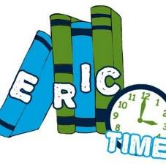
E.R.I.C:
‘ERIC’ stands for ‘Everyone Reading in Class’. This is a time for pupils to enjoy their own reading and is a much loved part of the day!

Poetry Day:
This year, we will be introducing termly poetry days, where each class will complete a variety of exciting activities based around a particular poem or poet.

Monster Phonics:
Monster Phonics is the scheme that we follow at Anson to teach early reading. Monster Phonics uses a colour coded grapheme system linked to monster characters. The colour-coded grapheme system is unique to Monster Phonics; each coloured grapheme is paired with a monster character that makes the same sound to give audio-visual prompts that help children ‘see’ each sound within a word and pronounce it correctly. We follow the Monster Phonics programme in Reception and Key Stage 1. The children will have a daily phonics lesson, full of exciting, purposeful, multisensory phonics teaching and learning experiences.

More information about Monster Phonics can be found by visiting the ‘Phonics’ page on our website: https://anson.staffs.sch.uk/our-school/curriculum/phonics .

Guided Reading:
In KS1, Guided Reading is a time for children to put what they have learnt in their phonics lessons into action! Children will read a Monster Phonics book that has been chosen to match their reading level with an adult and a small group. The children will read the story aloud to develop their decoding and fluency and will be asked a variety of questions that link to the story to help develop their comprehension ability. This story will then be taken home to be re-explored with families as repetition is a vital part of language and comprehension development in younger children.

In KS2 children participate in Whole Class Reading Lessons. The teacher selects high-quality pieces of children's literature or non-fiction texts that will challenge all pupils. Where possible, the text is linked to a relevant topic and used to benefit other subjects. During whole class reading sessions, the learning objective for the session is the same for all pupils. Everyone will have access to the same activities and levels of questioning but with differing levels of support provided depending on pupil needs. The teacher reads the text to the class, modelling fluency, intonation and comprehension, and pupils follow the text. The teacher uses skilful questioning and discussion to help pupils get to grips with new vocabulary and develop their understanding of the text. Then, pupils work on activities that help them to develop their comprehension of the text. Depending on the activity, pupils may work in mixed-ability groups, pairs or by themselves.

Individual readers:
In Reception and KS1, children are heard reading once a week by an adult in school. The children really enjoy this 1-1 time and delight in the opportunity to discuss their reading. If you would like to volunteer to hear children read, please contact the office. Your help would be much appreciated by staff and the children.

Reading books in each class:
In Class 1, your child will bring home a variety of books each week. Your child will receive a Monster Phonics book matched to the phonics stage your child is working at and a book band book that you can share at home. These books will be changed once a week, on a Monday. Your child will also visit the library on a Monday to choose a Recommended Read book or Library book. Reception children also have free access to a cosy book corner throughout their day, where they can snuggle up with a story and a teddy, share stories with their friends or act out the stories using story props. Our online reading platform ‘Bug Club’ is also available, where children can read books set to their level or have them read aloud to them. The platform also asks comprehension questions based on what has been read.
Logins for Bug Club can be found in the front of your child’s diary.

In Class 2, your child will come home with a variety of books each week. Your child’s book band books will be changed once a week, on a Monday. In addition to this, your child’s Monster Phonics book will be changed once a week, on a Friday. Your child also has the option of taking home a Recommended Read or a Library book each Monday. Our online reading platform ‘Bug Club’ is also available, where children can read books set to their level or have them read aloud to them. The platform also asks comprehension questions based on what has been read.
Logins for Bug Club can be found in the front of your child’s diary.

In Class 3, children will have two books from our coloured book band system (unless they have completed the scheme and are a 'free reader', in which case they will choose their own book from our selection or from home). One is to read at home and one is to stay at school so they always have an appropriate book available for ERIC and extra reading opportunities. As long as it is recorded in their diary, these books can be changed as soon as they have been read and understood, and the children are able to do this independently. Our library day is Tuesday and every child will have the chance to take home a library book. It may be one they can read themselves, or it may be a book that interests them and they can read with a little support at home. Every child also has a 'Recommended Read' book. Since some of these books are quite lengthy, the children will be finishing their books at different times, so once this has been read (and a book review completed) they can change whenever they need to.

In Class 4, your child will have access to a vast array of texts. If they are still working on the book bands, they will be given one of these to read and this will be changed when your child has finished their book. In addition to this, all pupils have access to a library book or one of our class recommended reading books. Pupils who read one of our recommended reading books have the opportunity to complete a book review of the text in order to enter themselves into our Recommended Reading competition. As always it is so important that your child is reading each day to continue developing this skill and we really appreciate any support you can provide them with this at home. Please remember to write in your child's diary when they read both independently or with an adult.

We are really passionate about developing children’s love of reading and hope that with your help we can create a generation of children who are avid readers for life!
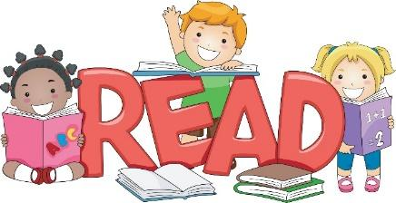
Yours Sincerely,

All of the team at Anson

