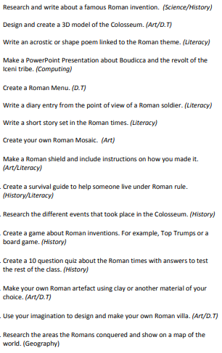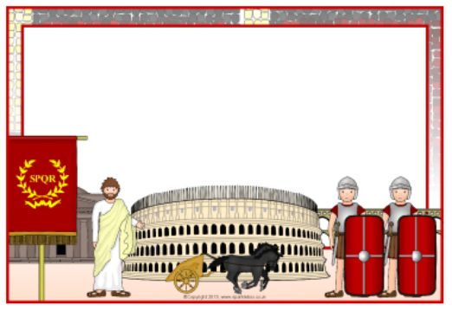

This half term, we would like the children to focus on the topic of   
**Roman Invaders!**

Here are your home learning activities for our topic. You need to choose at least 1 activity from the boxes below to complete over the half term.  
All home learning should be brought into school by **Tuesday 20th April** to be shared with the class.  
(Any items brought into school will be quarantined appropriately).