Spelling test: Year 5
Given: 29.3.22
Test: 5.4.22
Spellings
four
nine
fourteen
nineteen
green
pink

Spelling test: Year 5
Given: 29.3.22
Test: 5.4.22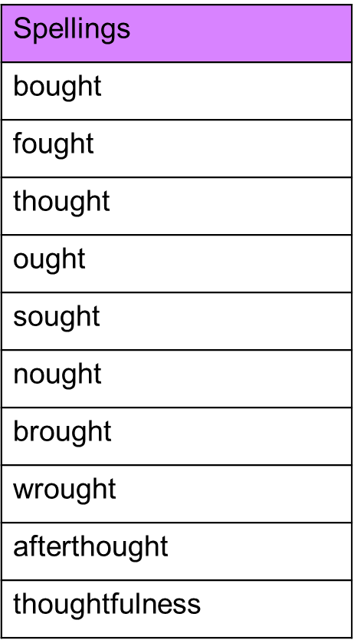

Spelling test: Year 6
Given: 29.3.22
Test: 5.4.22