Spelling Test: Year 5
Given: 3.3.22
Test: 8.3.22
Rule: High Frequency Words
Spellings
very
Tuesday
Sunday
March
August
month

Spelling test: Year 5
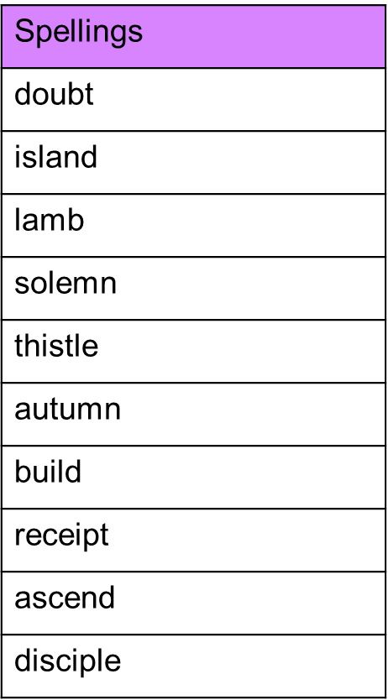
Given: 3.3.22
Test: 8.3.22

Spelling test: Year 6
Given: 3.3.22
Test: 8.3.22