Spelling test: Year 5
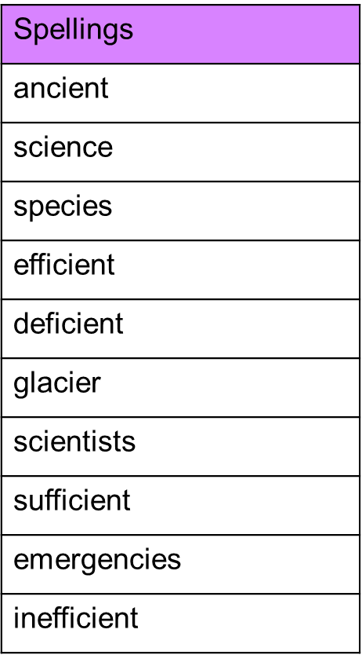
Given: 15.3.22
Test: 22.3.22

Spelling test: Year 6
Given: 15.3.22
Test: 22.3.22
