Spelling test: Year 5
Given: 22.3.22
Test: 29.3.22
Spellings
very
Tuesday
Sunday
March
August
month

Spelling test: Year 5
Given: 22.3.22
Test: 29.3.22
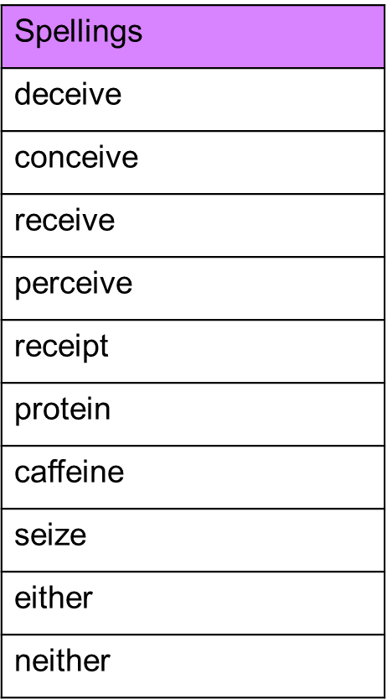

Spelling test: Year 6
Given: 22.3.22
Test: 29.3.22
