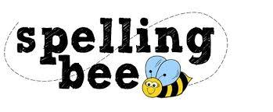



| today | come |
| --- | --- |
| said | was |
| were | your |
| house | his |
| friend | once |
| love | pull |
| our | there |
| put | school |

