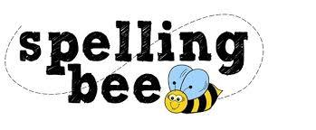



| door | every |
| --- | --- |
| pretty | money |
| behind | half |
| find | again |
| should | even |
| grass | who |
| because | sugar |
| eye | clothes |
| people | water |
| house | move |

