-----------
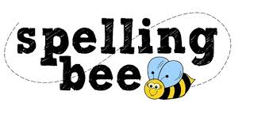

Year 3&4 Spring Term

difficult | separate
particular | special
peculiar | straight
perhaps | strange
popular | strength
position | suppose
possible | surprise
potatoes | therefore
pressure | though
probably | although
promise | thought
purpose | through
quarter | various
question | weight
recent | woman
regular | women
reign | Wednesday
remember | eighty
sentence | August

