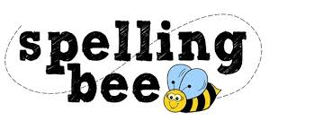

Year 5& 6 Autumn Term 2022

develop | hindrance
achieve | communicate
amateur | bruise
excellent | lightning
competition | strength
determined | shoulder
familiar | surprise
environment | muscle
mischievous | symbol
frequently | although
vehicle | sufficient
curiosity | through
prejudice | nuisance
identity | weight
vegetable | occupy
individual | occur
rhyme | opportunity
recognise | parliament
according | persuade

