|  |  |  |  |
| --- | --- | --- | --- |
| |  | | --- | | **Year 3 Spellings** |   **Spelling Test: Year 3 (List 12)**  **Spellings given:** 26/11/2024  **Test On:** 03/12/2024  Spelling Rule: challenge words | |  | | --- | | **Year 4 Spellings** |   **Spelling Test: Year 4 (List 12)**  **Spellings given:** 26/11/2024  **Test On:** 03/12/2024  Spelling Rule: words with irregular spelling patterns |

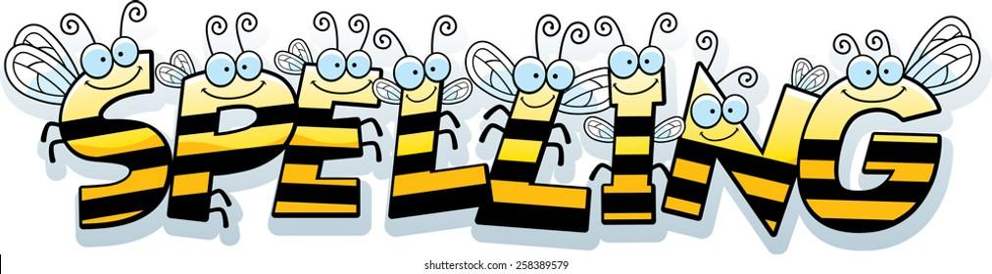

Remember, Mrs Walmsley uploads your spellings weekly on to Spelling Shed. So, you can practise on the website or app too!