Year 3 Spellings  Spelling Test: Year 3 (List 21)  Spellings given: 19/03/2024  Test On: 09/04/2024  Spelling Rule: Words ending in ‘-ly’ where the base word ends in ‘-le’  gently  simply  humbly  nobly  durably  terribly  incredibly  responsibly  wrinkly  possibly | Year 4 Spellings  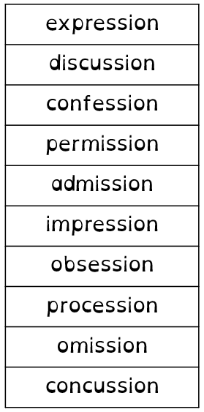  Spelling Test: Year 4 (List 21)  Spellings given: 19/03/2024  Test On: 09/04/2024  Spelling Rule: Words ending in ‘-ssion’
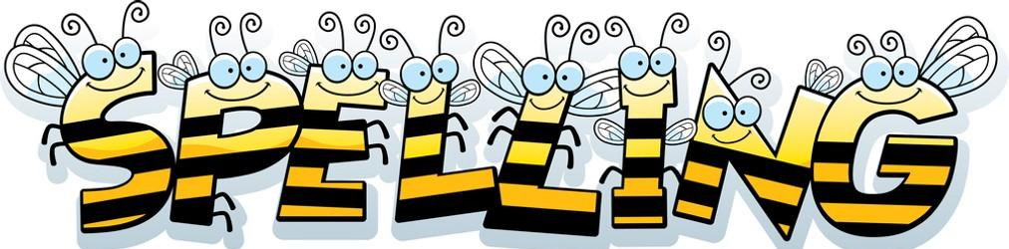
Remember, Mrs Walmsley uploads your spellings weekly on to Spelling Shed. So, you can practise on the website or app too!

