Year 3 Spellings  Spelling Test: Year 3 (List 22)  Spellings given: 09/04/2024  Test On: 16/04/2024  Spelling Rule: Words ending in ‘-ly’ where the base word ends in ‘-ic’  basically  frantically  logically  magically  publicly  dramatically  automatically  specifically  historically  tragically | Year 4 Spellings  Spelling Test: Year 4 (List 22)  Spellings given: 09/04/2024  Test On: 16/04/2024  Spelling Rule: Words ending in ‘-cian’  musician  electrician  politician  mathematician  technician  optician  beautician  physician  dietician  magician
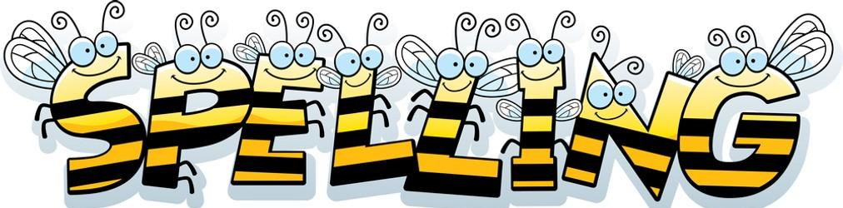
Remember, Mrs Walmsley uploads your spellings weekly on to Spelling Shed. So, you can practise on the website or app too!

