Year 3 Spellings  Spelling Test: Year 3 (List 23)  Spellings given: 16/04/2024  Test On: 23/04/2024  Spelling Rule: Words ending in ‘-ly’ - exceptions  truly  slyly  fully  duly  shyly  wholly  drily  coyly  happily  daily | Year 4 Spellings  Spelling Test: Year 4 (List 23)  Spellings given: 16/04/2024  Test On: 23/04/2024  Spelling Rule: Words that are adverbs of manner  reluctantly  quickly  generously  unexpectedly  gently  curiously  furiously  seriously  victoriously  courteously
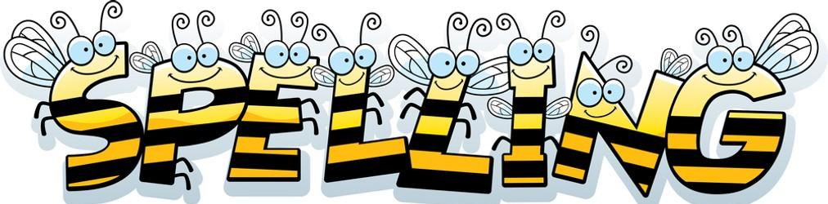
Remember, Mrs Walmsley uploads your spellings weekly on to Spelling Shed. So, you can practise on the website or app too!

