Year 3 Spellings  Spelling Test: Year 3 (List 24)  Spellings given: 23/04/2024  Test On: 30/04/2024  Spelling Rule: Challenge Words  address  mention  arrive  occasionally  certainly  probably  experience  reign  history  sentence | Year 4 Spellings  Spelling Test: Year 4 (List 24)  Spellings given: 23/04/2024  Test On: 30/04/2024  Spelling Rule: Challenge Words  surprise  separate  group  height  potatoes  though  particular  through  caught  woman  Spelling Rule: Words ending in ‘-ssion’
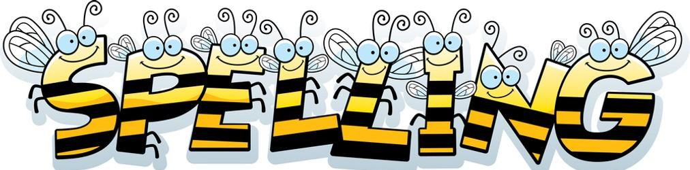
Remember, Mrs Walmsley uploads your spellings weekly on to Spelling Shed. So, you can practise on the website or app too!

