Year 3 Spellings  Spelling Test: Year 3 (List 25)  Spellings given: 30/04/2024  Test On: 07/05/2024  Spelling Rule: words with the suffix ‘-er’  teacher  stretcher  dispatcher  catcher  butcher  richer  scorcher  preacher  cruncher  watcher | Year 4 Spellings  Spelling Test: Year 4 (List 25)  Spellings given: 30/04/2024  Test On: 07/05/2024  Spelling Rule: Homophones  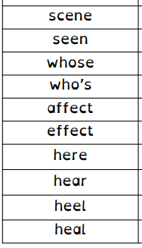
Remember, Mrs Walmsley uploads your spellings weekly on to Spelling Shed. So, you can practise on the website or app too!

