Year 3 Spellings  Spelling Test: Year 3 (List 26)  Spellings given: 07/05/2024  Test On: 14/05/2024  Spelling Rule: Words here the digraph ‘ch’ makes a /k/ sound  scheme  chorus  echo  chemist  character  stomach  monarch  school  anchor  chaos | Year 4 Spellings  Spelling Test: Year 4 (List 26)  Spellings given: 07/05/2024  Test On: 14/05/2024  Spelling Rule: Words with ‘c’ before ‘i’ and ‘e’  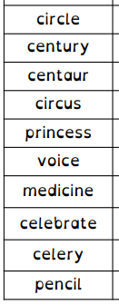
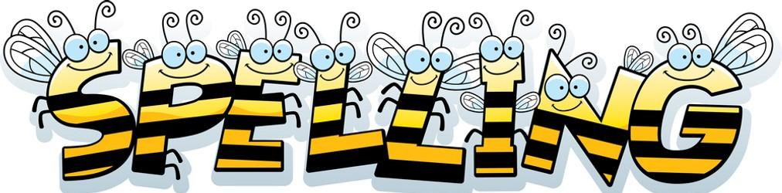
Remember, Mrs Walmsley uploads your spellings weekly on to Spelling Shed. So, you can practise on the website or app too!

