|  |  |  |  |  |  |  |  |  |  |  |  |  |  |
| --- | --- | --- | --- | --- | --- | --- | --- | --- | --- | --- | --- | --- | --- |
| |  | | --- | | **Year 3 Spellings** |   **Spelling Test: Year 3 (List 29)**  **Spellings given:** 13/05/25  **Test On:** 20/05/25  Spelling Rule: homophones   |  | | --- | | bawl | | ball | | break | | brake | | male | | mail | | fair | | fare | | berry | | bury | | |  | | --- | | **Year 4 Spellings** |   **Spelling Test: Year 4 (List 29)**  **Spellings given:** 13/05/25  **Test On:** 20/05/25  Spelling Rule: Words with prefixes super- anti- and auto- |

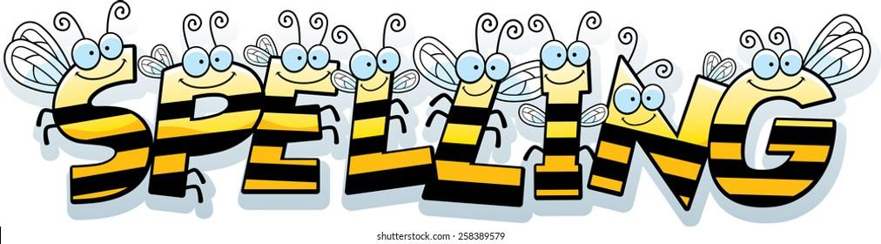

Remember, Mrs Walmsley uploads your spellings weekly on to Spelling Shed. So, you can practise on the website or app too!