|  |  |  |  |  |  |  |  |  |  |  |  |  |  |
| --- | --- | --- | --- | --- | --- | --- | --- | --- | --- | --- | --- | --- | --- |
| |  | | --- | | **Year 3 Spellings** |   **Spelling Test: Year 3 (List 35)**  **Spellings given:** 8/7/25  **Test On:** 15/7/25  Spelling Rule: Revision Words   |  | | --- | | teacher | | scheme | | history | | mention | | bawl | | crescent | | eighteen | | regular | | mane | | disable | | |  | | --- | | **Year 4 Spellings** |   **Spelling Test: Year 4 (List 35)**  **Spellings given:** 8/7/25  **Test On:** 15/7/25  Spelling Rule: Revision words   |

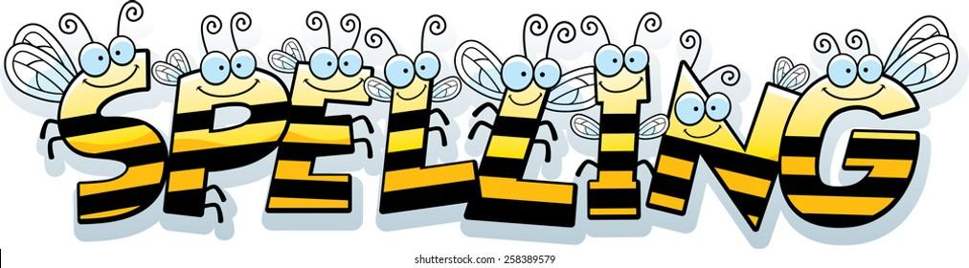

Remember, Mrs Walmsley uploads your spellings weekly on to Spelling Shed. So, you can practise on the website or app too!