|  |  |  |  |
| --- | --- | --- | --- |
| |  | | --- | | **Year 3 Spellings** |   **Spelling Test: Year 3 (List 7)**  **Spellings given:** 15/10/2024  **Test On:** 22/10/2024  Spelling Rule: words with the prefix re- | |  | | --- | | **Year 4 Spellings** |   **Spelling Test: Year 4 (List 7)**  **Spellings given:** 15/10/2024  **Test On:** 22/10/2024  Spelling Rule: Words ending in ‘-ation’ |

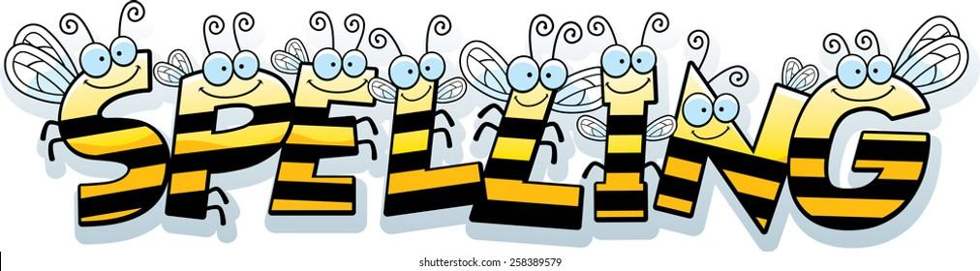

Remember, Mrs Walmsley uploads your spellings weekly on to Spelling Shed. So, you can practise on the website or app too!