Spelling Test: Year 1
Given: 16.09.19
Test: 23.09.19

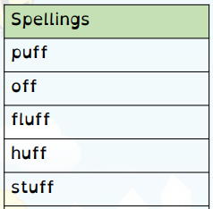

Spelling Test: Year 2

Given: 16.09.19
Test: 23.09.19

