Spelling Test: Year 4
Given: 08.09.20
Test: 15.09.20
Spelling Rule: Words ending with the /f/, /l/, /s/, /z/ or /k/ sound in English almost always have double

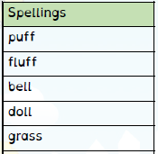

Spelling Test: Year 3
Given: 08.09.20
Spelling Test: Year 4
Given: 08.09.20
Test: 15.09.20
Spelling Rule: Homophones

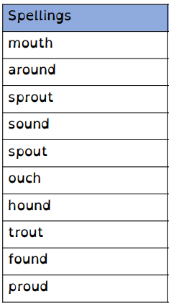
Test: 15.09.20
Spelling Rule: The /ow/ sound spelled ‘ou.’
Found often in the middle of words,
sometimes at the beginning and
very rarely at the end of words.

