Spelling Test: Year 4
Given: 07.09.21
Test: 14.09.21
Spelling Rule: Homophones

Spelling Test: Year 3
Given: 07.09.21
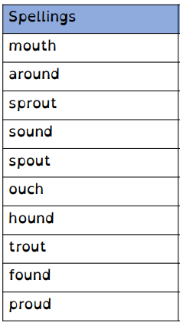
Test: 14.09.21
Spelling Rule: The /ow/ sound spelled ‘ou.’
Found often in the middle of words,
sometimes at the beginning and
very rarely at the end of words.

