Spelling Test: Year 3
Spellings given: 07/09/2022
Test On: 13/09/2022
Spelling Rule: The /ow/ sound spelled ‘ou.’
Found often in the middle of words,
sometimes at the beginning and
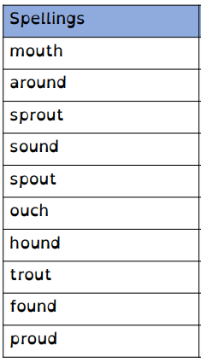
very rarely at the end of words.
Remember, Mrs Duffy uploads your spellings weekly on to Spelling Shed. So, you can practise on the website or app too!

Spelling Test: Year 4
Spellings given: 07/09/2022
Test On: 13/09/2022
Spelling Rule: Homophones

